



**Module Code & Module Title**

**CC4057NT Introduction to Information System**

**Assessment Weightage & Type**

**60% Group Coursework**

**Year and Semester**

**2025 Spring, 1st Semester**

|  |  |  |  |
| --- | --- | --- | --- |
| **Name** | **College ID** | **London Met ID** | **Group** |
| **Milan Timalsena** | **np05cp4s250155** | **24058933** | **L1C15** |
| **Bipan Subedi** | **np05cp4s250112** | **24058923** | **L1C15** |
| **Rabina Khatri** | **np05cp4s250053** | **24058939** | **L1C15** |
| **Sumit Dhakal** | **np05cp4s250057** | **24059019** | **L1C15** |
| **Krishman Subedi** | **np05cp4s250061** | **24058979** | **L1C15** |

**Assignment Due Date:**

**Assignment Submission Date:**

**Submitted To: Ajayraj Bhattarai**

*I confirm that I understand my coursework needs to be submitted online via MySecondTeacher under the relevant module page before the deadline in order for my assignment to be accepted and marked. I am fully aware that late submissions will be treated as non-submission and a marks of zero will be awarded.*

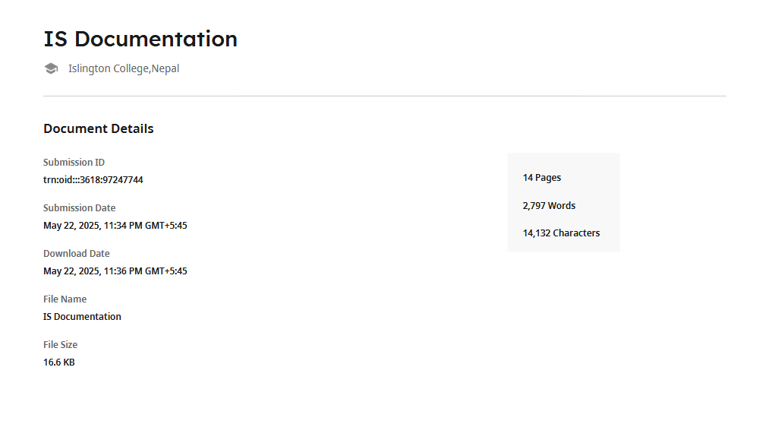

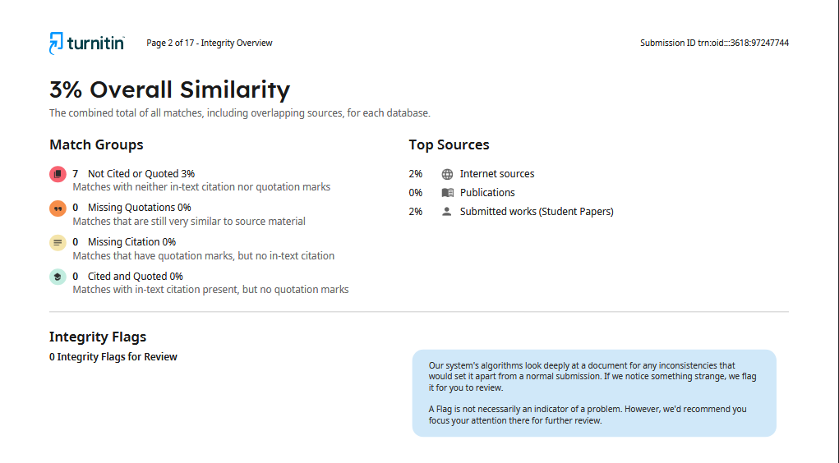

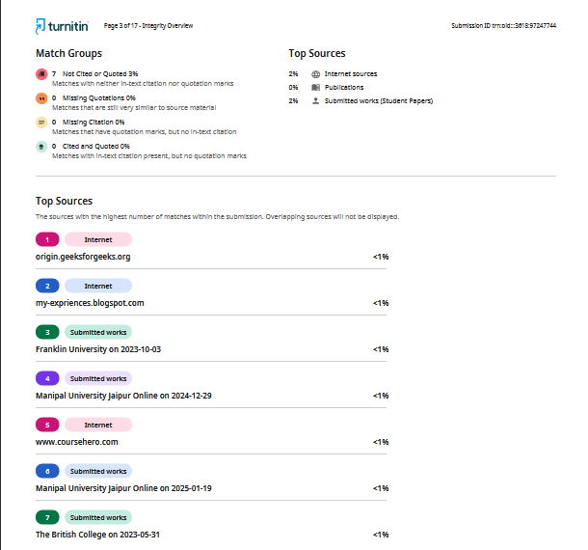

**Contents**

1. Introduction to Project 9

Our website key features: 9

1.1 Aims and Objectives 10

1.2 HTML 10

1.3 CSS 11

1.4 JavaScript 12

1.5 Balsamiq 12

1.6 Sublime Text 14

1.7 MS Word 15

2. Wireframe 15

2.1 Home Page 15

2.2 Product Page 19

2.3 About Us page 23

2.4 Blog Page 25

2.5 Research Page 28

3. Testing 32

3.1 Test 1 Checking the item add to cart 32

3.2 Test 2 Checking navbar hover effect 32

Checking navbar hover effect 32

3.3 Test 3 checking newsletter subscription 33

3.4 Test 4 checking internal link 34

3.5 Test 5 Checking external link 34

3.6 Test 6 Checking order completion Message 35

4. Tags used 36

4.1 div Tag 37

4.2 meta tag 37

4.3 img tag 37

4.4 form tag 38

5. CSS Types 38

5.1 Inline CSS 38

5.2 Internal CSS 39

5.3 External CSS 40

6. Conclusion 41

7. References 42

8. Appendix 42

8.1 Home Page HTML 42

8.2 Home Page CSS 61

8.3 Navbar CSS 69

8.4 Footer CSS 79

8.5 Product Page Html 87

8.6 Product page CSS 123

8.7 Product page Women section HTML 134

8.9 Product Page product HTML 154

8.10 Product page product CSS 161

8.11 About US HTML 166

8.12 About Us CSS 172

8.13 Our team section HTML 176

8.14 Our Team CSS 184

8.15 Individual page HTML and CSS 189

8.16 Blog page HTML 196

8.17 Blog page CSS 204

8.18 Research page HTML 206

8.19 Research page CSS 222

8.20 Newsletter js 237

8.21 Order form HTML 238

8.22 Order form CSS 242

8.23 Order form js 246

**Table of Figures**

Figure 1 HTML (Hyper Text Markup Language) 2

Figure 2 CSS (Cascading Style Sheet) 3

Figure 3 Java Script 4

Figure 4 Balsamiq 5

Figure 5 Balsamiq Wireframe Example 5

Figure 6 Sublime Text 6

Figure 7 MS Word 7

Figure 8 Wireframe Of Home Page 8

Figure 9 Home page 10

Figure 10 Wireframe of Product Page 11

Figure 11P product Page (Men Collection) 12

Figure 12 Product page (Women Collection) 13

Figure 13 Order form 14

Figure 14 Order complete message 14

Figure 15 Wireframe of About Us 15

Figure 16 About Us Page 17

Figure 17 Wireframe of Blog Page 18

Figure 18 Blog Page 19

Figure 19Wireframe Of Research Page 21

Figure 20 Research Page 22

Figure 21 Research Page 23

Figure 22Test 1 Checking the item add to cart 24

Figure 23 Navbar hover effect 25

Figure 24 newsletter subscription 25

Figure 25 checking internal link 26

Figure 26 Checking external link 27

Figure 27 Entering details in order form 28

Figure 28 Order message displayed successfully 28

Figure 29 Example of div tag used in Home page 29

Figure 30 Meta Tag 29

Figure 31 img tag 29

Figure 32 Inline CSS 31

Figure 33 Internal CSS 31

Figure 34 external CSS 32

Table of Tables

Table 1 Checking the item add to cart 24

Table 2 Checking navbar hover effect 24

Table 3 checking newsletter subscription 25

Table 4 checking internal link 26

Table 5 Checking external link 26

Table 6 Checking order completion Message 27

# Introduction to Project

In today’s world e-commerce has become the easiest and fastest way to buy and sells something to users in just a few clicks. By inspecting this thing, We Velvra team develop e-commerce website which is mean to sell various footwear. Our website contains a home page, product page, blog page, about us page, and a research page. Homepage provides a brief overview of the content and purpose of all pages and can see the trending items, new arrivals section and a top sales section also some of customers review. On the product page they can buy different Footwear category wise for Men and Women & Kids. Visitors can see various kinds of shoes: casual, formal, athletic, and luxury footwear in best price range. Footwear relates to style trends, advantages of material, and modern technology’s impact on shoe design, these topics are discussed in the blog page. Customer feedback options and contributions from each team member are showcased in the About Us page. The research page will outline the tools and steps and references used in building the website.

### Our website key features:

* Everyone who stops by the Latest Trends Home Page encounters hand-picked customer favorites combined with newly listed arrivals at the forefront to maintain up-to-date fashion standards.
* The website features a Product Section dedicated to footwear merchandise designed for both Men and Women along with Kids that exists through organizing all foot coverings into casual and formal categories as well as athletic and luxury classifications.
* The Blog Page explores two main topics: style trend coverage and sustainable shoe material introductions and examines the impact of technological advancements on modern shoewear design.
* Our About Us Page presents information about our enthusiastic team members and tells the story of our brand alongside authentic customer testimonials.
* Our Research Page openly presents all the tools used alongside each step taken toward site development while providing the complete list of references used.
* Through Velvra you will experience comfortable shoes producing both class and confidence during every step because we blend fashion and function.
* Your shoe choice starts with an Explorative search that leads you to your ideal pick and delivers a power-packed upgrade to your style.

### 1.1 Aims and Objectives

The major aim of this project is to develop a functional website that sells various footwear which changes our theoretical knowledge on web development into practical skills. Also, providing the costumer the We used our understanding of HTML, CSS, and JavaScript to create a working and good-looking site. This will also enhance our proficiency in CSS and HTML. Provides a idea of on doing this what will happen the website, provides leadership as well as working in team. Using interactive features to give better customer experience and satisfaction Through this project, we also looked at creative design options, interactive features, and user-friendly layouts.

### 1.2 HTML



Figure 1 HTML (Hyper Text Markup Language)

HTML refers to Hyper Text Markup Language. The first version of HTML was written by Tim Berners-Lee and it was published in 1993. HTML is a Markup language that is used in creating the webpages that is shown in the web browser. It is not case sensitive. HTML consists of various tags like head, body, div, section, footer, paragraph, meta, bold, and so on. Each tags have its own vital role in creating the web pages. All HTML files are saved using the HTML extension.

### 1.3 CSS



Figure 2 CSS (Cascading Style Sheet)

Cascading Style Sheet (CSS) is the styling tool which helps us to create a proper good looking website. HTML is a structure then the CSS is a Architecture. Where we can style our webpages using different font, color, margin, padding shape, size, we cannot create a proper shape only using HTML but if we use CSS then we can adjust andx changed the shape, size border , color of our website.

### 1.4 JavaScript

Figure 3 Java Script

JavaScript is one of the widely used scripting language in today’s world.it is a powerful scripting language from where we can make a proper functional website by adding it on HTML CSS. It is mainly used for user better experience and functional. By this we can display alert message to show user and instruct user, warn user about what to do and what not to do. We can also use this in app development . also we can even use it to build virtual reality applications and artificial intelligence. we can be able to create Mobile App development, Backend development and many more. JavaScript uses databases like CouchDB and MongoDB. Many framework and libraries like Angular and React makes easier to create complex websites, with the help of Node Package Manager

### 1.5 Balsamiq

Blsamiq is a tools which is available in app and web both form. It is a wireframing software. The main purpose of using Balsamiq is to design the scratch of the project. Here the structure is made after proper planning and research. We sketch here a outline of project. The drag and drop features of it makes the website more User friendly and we can draw a sketch in interactive way.Also, it is i=easy to use

Figure 4 Balsamiq



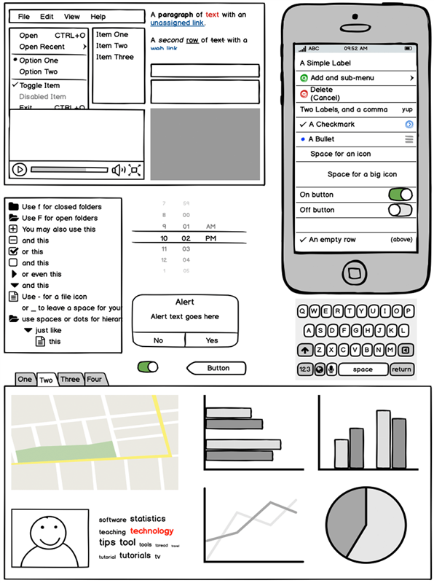

Figure 5 Balsamiq Wireframe Example

### Sublime Text Icon1.6 Sublime Text

Figure 6 Sublime Text

Sublime Text displays text and source code in an editing environment which presents a basic user interface and provides code folding and syntax highlighting with built-in support for multiple programming and markup languages and search and replace with regex support alongside its integrated terminal window and customizable themes. The application runs on Windows and macOS and Linux with extension capability through Python-based plugins. Through Sublime Text's built-in Package Control system users can download community-contributed plugins and write their own plugins through the application's Python API. The evaluation version of Sublime Text can be used indefinitely after a free download because the software remains proprietary.

Our footwear e-commerce website development team builds the dynamic storefront using Sublime Text code editor which maintains power and lightness. By using Sublime Text our development staff manages to write quality code with minimal effort for editing and management. The software's auto-completion and syntax highlighting features include multi-line editing and interface simplicity that allow us to speed up our design and development work.

Sublime Text provides us the speed and flexibility that help us build responsive site layouts with HTML and CSS and add interactive elements with JavaScript and manage complex site files in our creative website development process.

### 1.7 MS Word

Figure 7 MS Word

Microsoft Word is a word-processing program, developed by Microsoft introduce on October 25, 1983 on the name Multi-Tool Word. It provides different tools to do different types of documents to user, from the simple to the complex, we can insert tables, modify font style, font size, color of the text and add images and directly print from it. Also we add headers, footers, and page numbers, many user use this for making question papers and documenting about something.

# Wireframe

Wireframe is a scratch view of any project done before the project is started. It is done to see how our project is going to look in a scratch form. Before any code is written, we need to plan what kind of website we are going to make.In this project we’ve done wireframe form Balsamiq

### 2.1 Home Page

The home point is the first page of website also known as entry point here we can see the different thin such as: 3D animated video of our upcoming product also user can see the trending section, new arrivals section and top sales section of the website, user can see the beautiful navigation on the top of page from where user can redirect of go to the another page of the webpage in a click. User can see different product with the best product with certain percentage of discount on it. Here user can see testimonial section where some of our happy customers review are shown. Our page contain footer section too from here user can see our contact information direct navigation towards other pages, also a user can subscribe our newspaper so that user can see our latest and upcoming 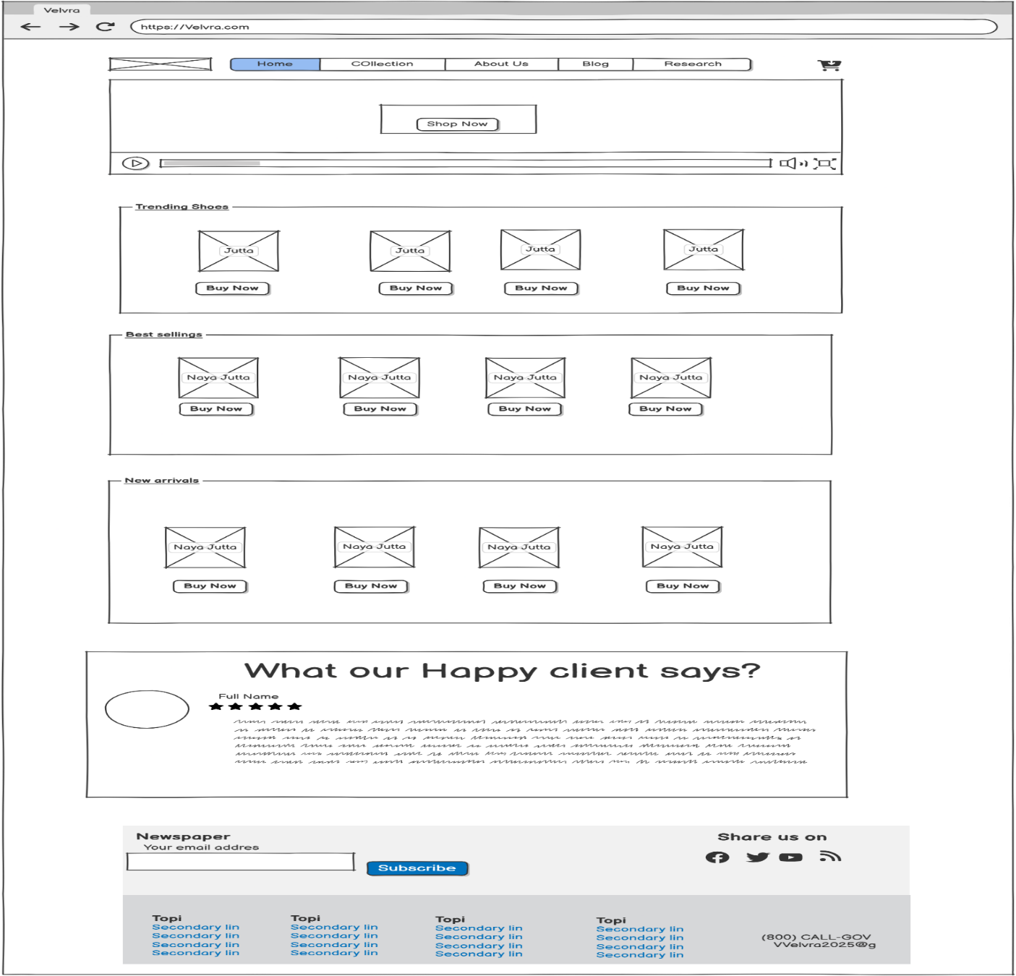product faster than others.

Figure 8 Wireframe Of Home Page

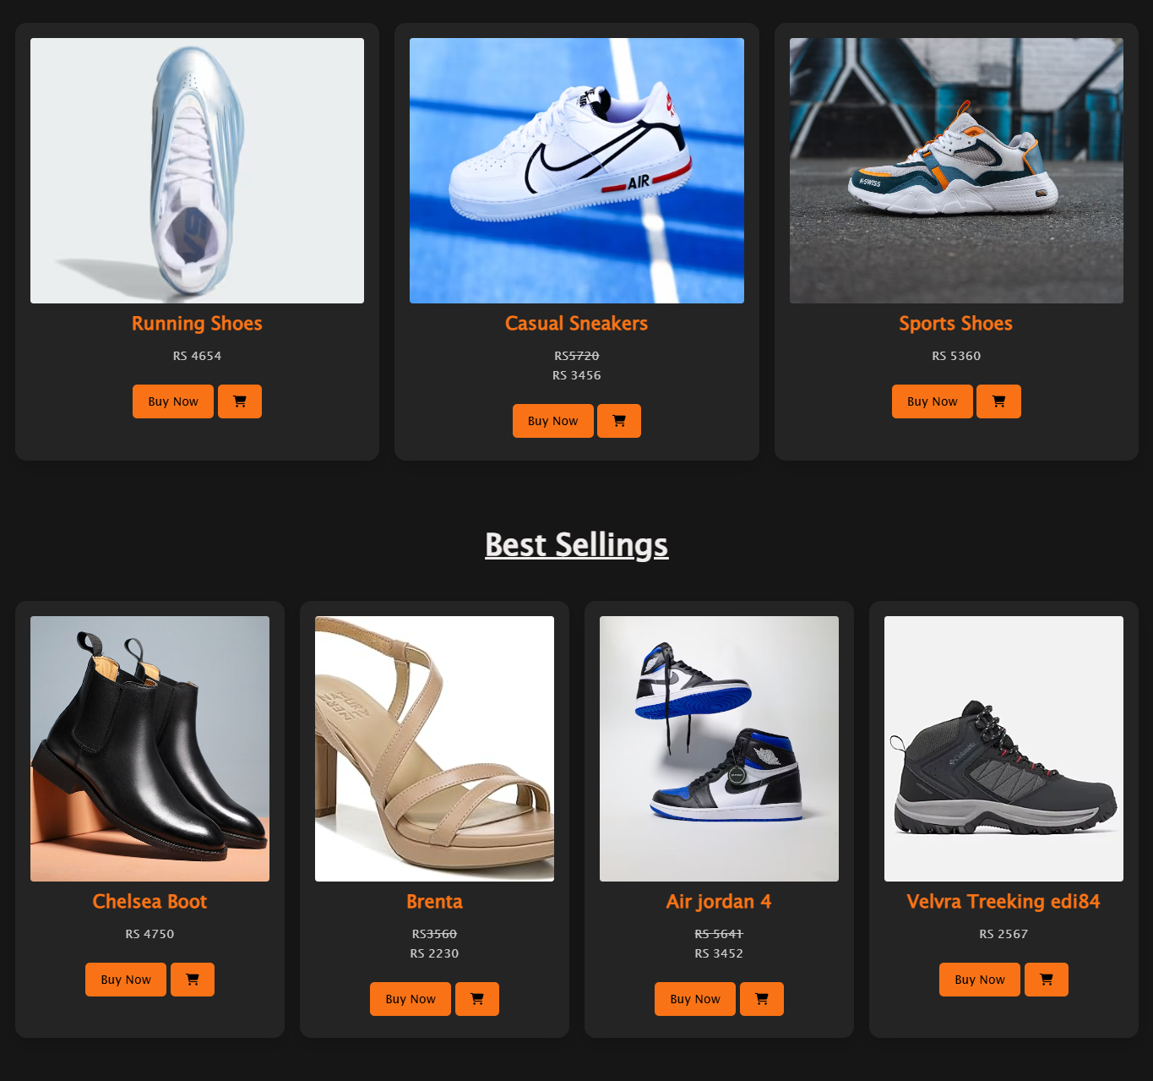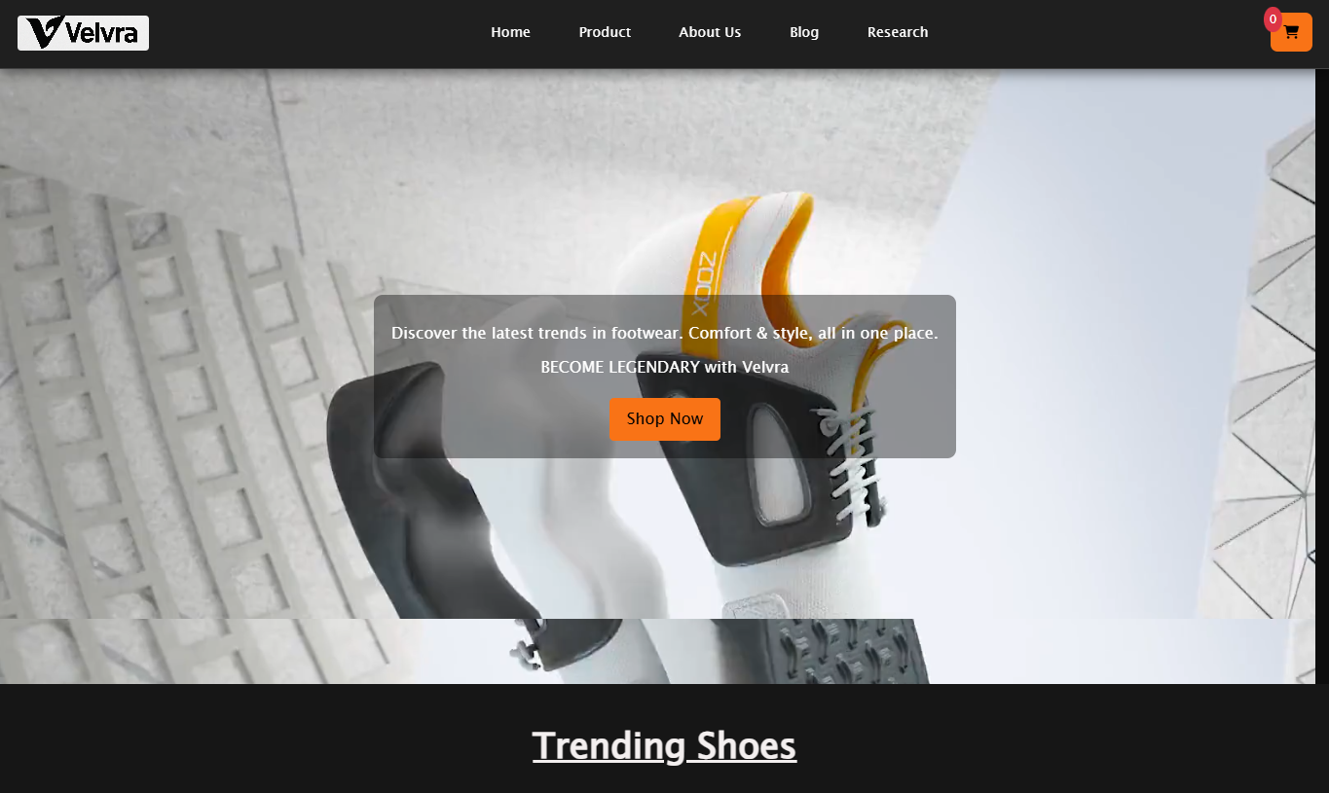

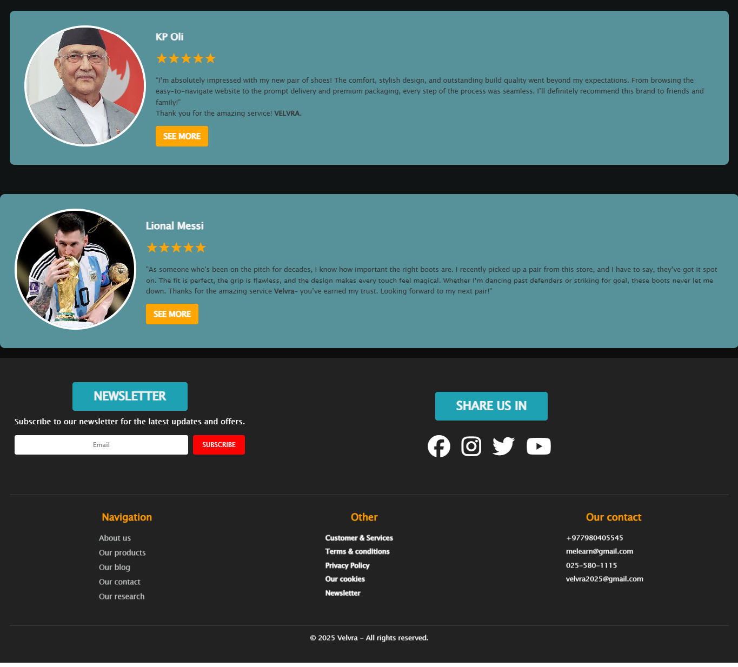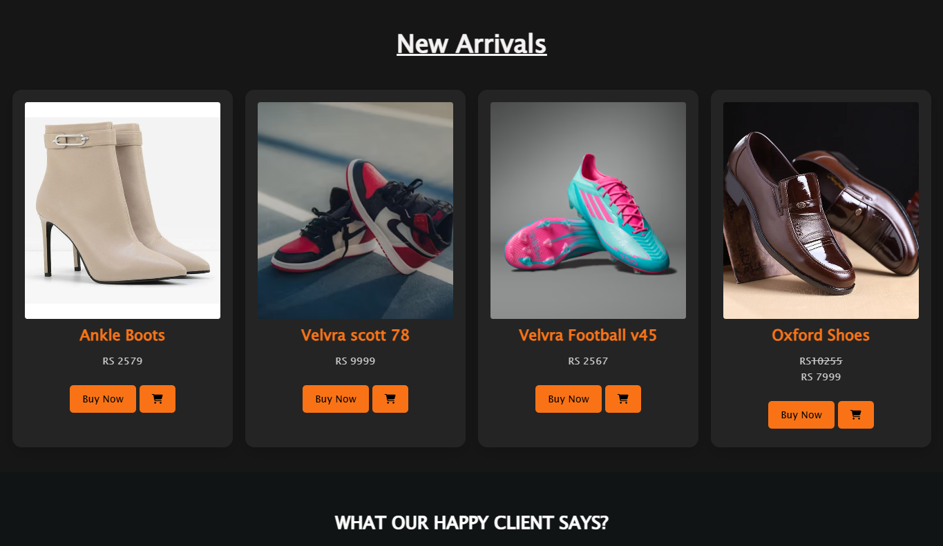

Figure 9 Home page

### Product Page

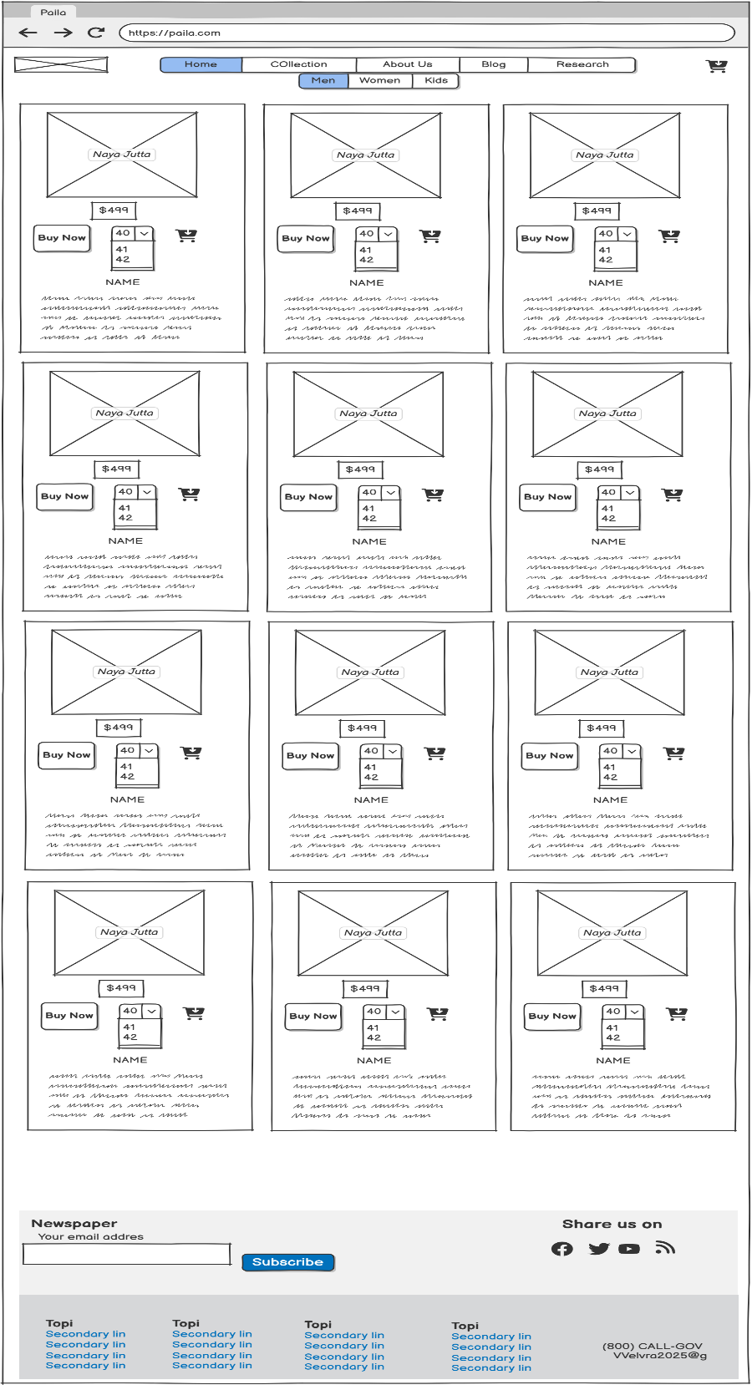It is our second page in this website. It also contains navigation on the top of page from where user can redirect of go to the other page of the website in a click. User can see different product with the best product with certain percentage of discount on it same as home page user can see here product category wise: Men, Women and kids. On the men section user can see another category casual wear, formal, and athletic wear. User can directly order the product by clicking buy now and fill up the delivery form. This page also contain footer section too from here user can see our contact information direct navigation towards other pages, also a user can subscribe our newspaper so that user can see the information of our latest and upcoming product faster.

Figure 10 Wireframe of Product Page

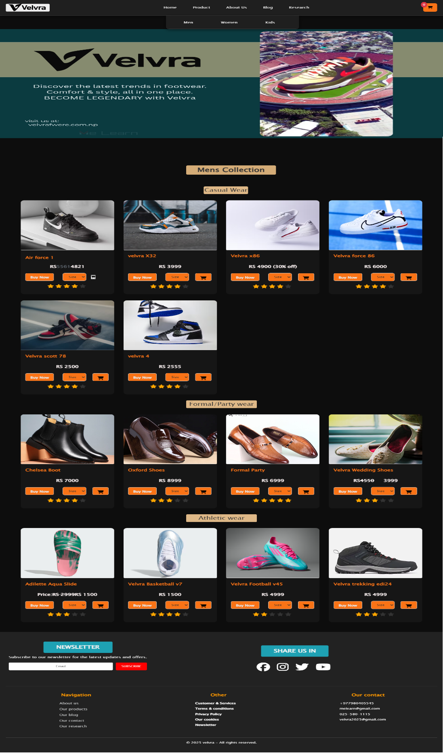

Figure 11P product Page (Men Collection)

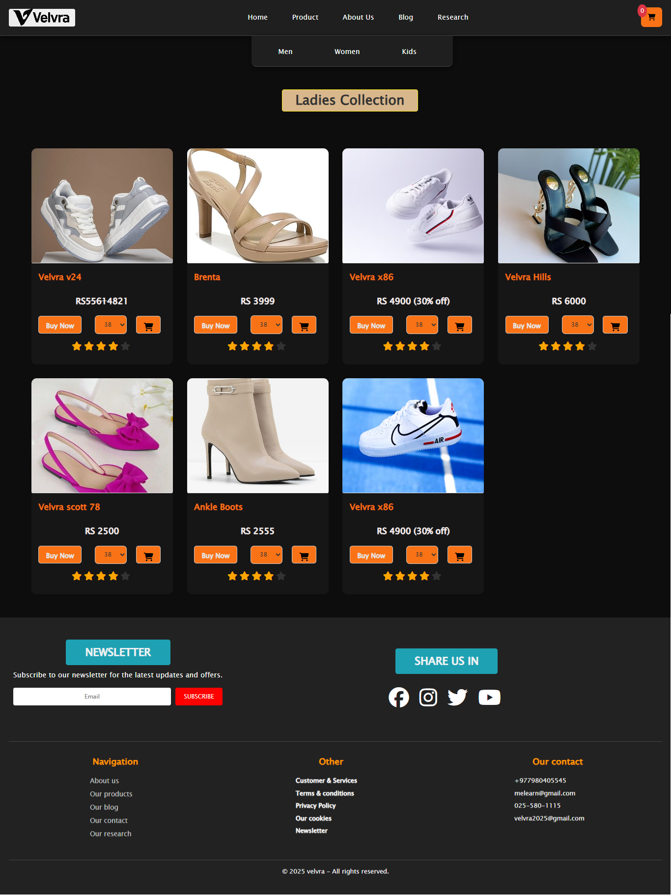

Figure 12 Product page (Women Collection)

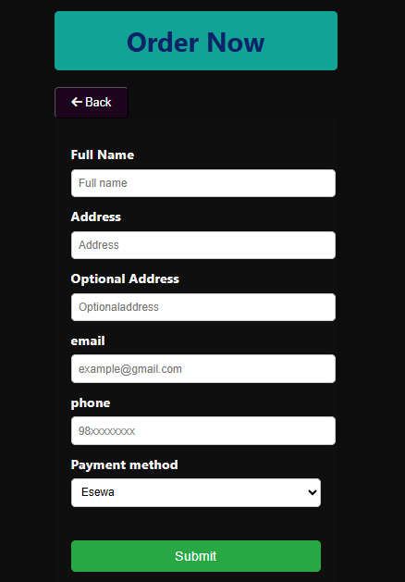

Figure 13 Order form

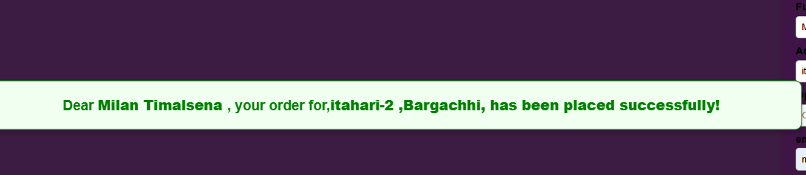

Figure 14 Order complete message

### About Us page

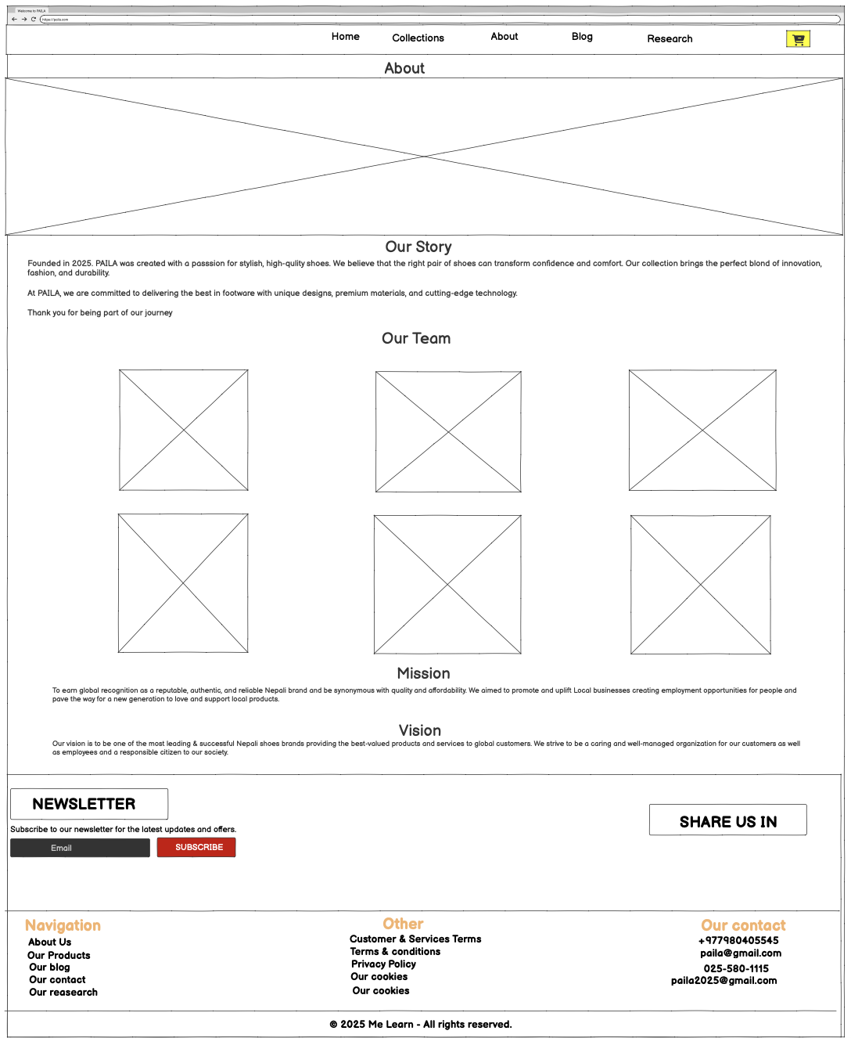This is the third page of our website. It also contains navigation on the top of page from where user can redirect of go to the other page of the website in a click. This webpage contains introduction and origin of our product website and brands, how/why it was founded, it also contains mission and objective of this brand velvra. Introduction of our team members and their roles this page also contains the feedback form where customer can give review. External link of social media of the website and the team members. This page also contains footer section too from here user can see our contact information direct navigation towards other pages, also a user can subscribe our newspaper so that user can see the information of our latest and upcoming product faster.

Figure 15 Wireframe of About Us

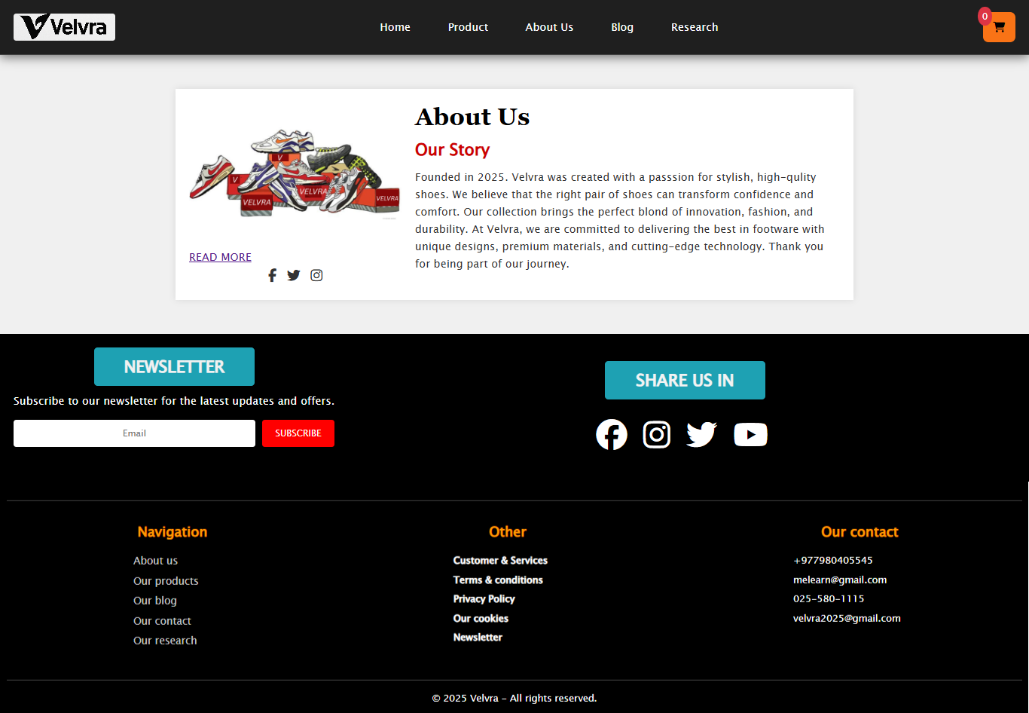

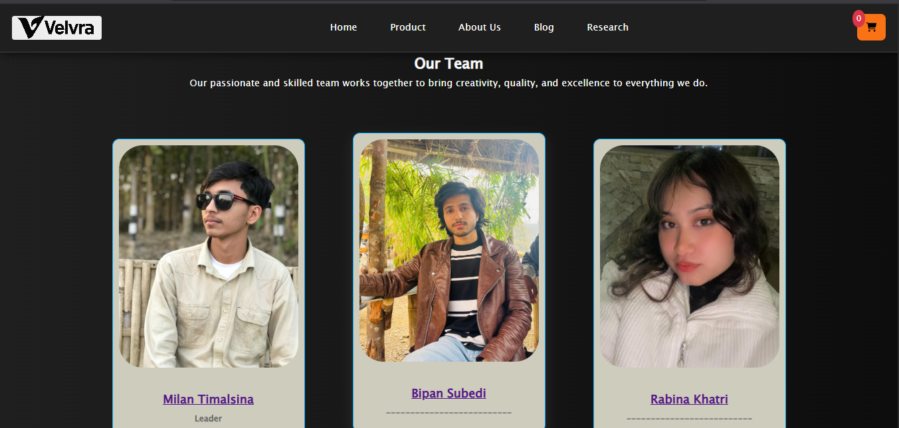

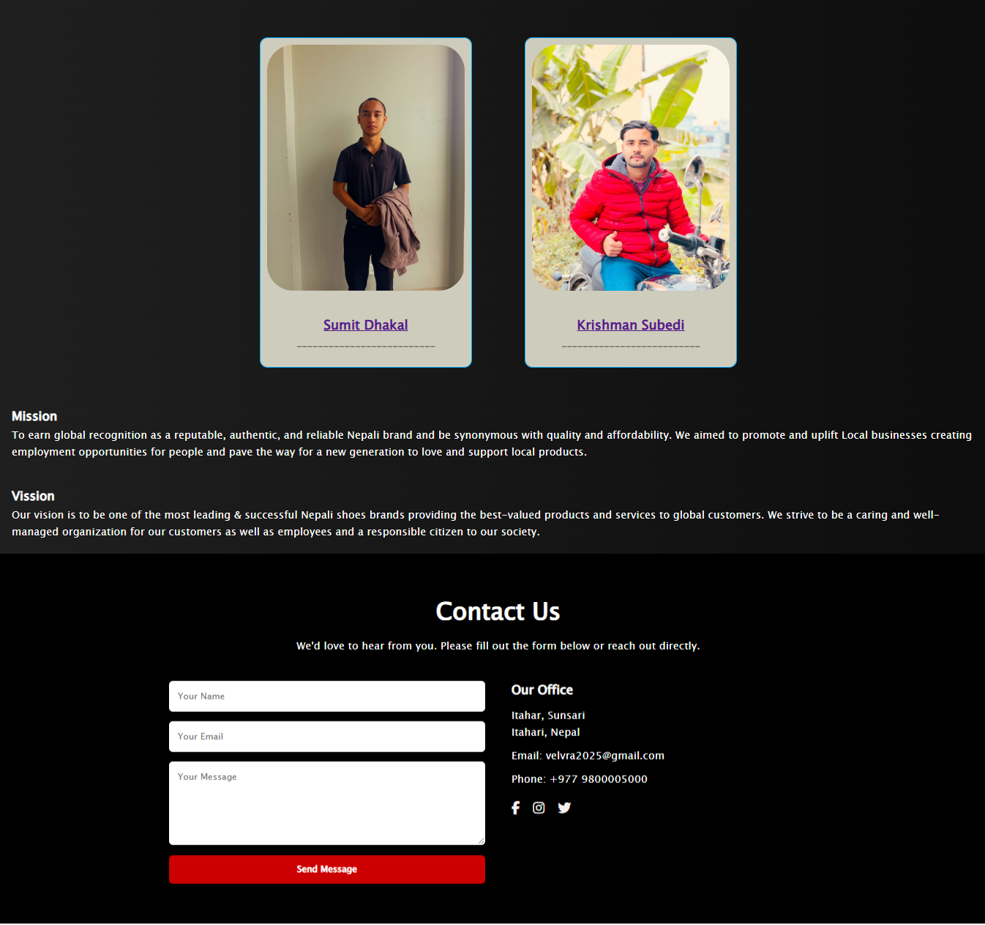

Figure 16 About Us Page

### Blog Page

our blog page, Our website offers visitors the educational content about footwear design trends and materials and style developments. Customers who visit this site get more than products. They will get education about all the modern fashion trends and advanced footwear industry technology.

The page addresses various topics which includes men, women and kids fashion trends for different seasons with shoe pairing instructions. The site's leading feature is sustainable footwear using eco-friendly materials and manufacturing ethics. Through our examination we see how shoewear's future develops using modern technologies including 3D printing and smart shoes and performance-enhancing features.

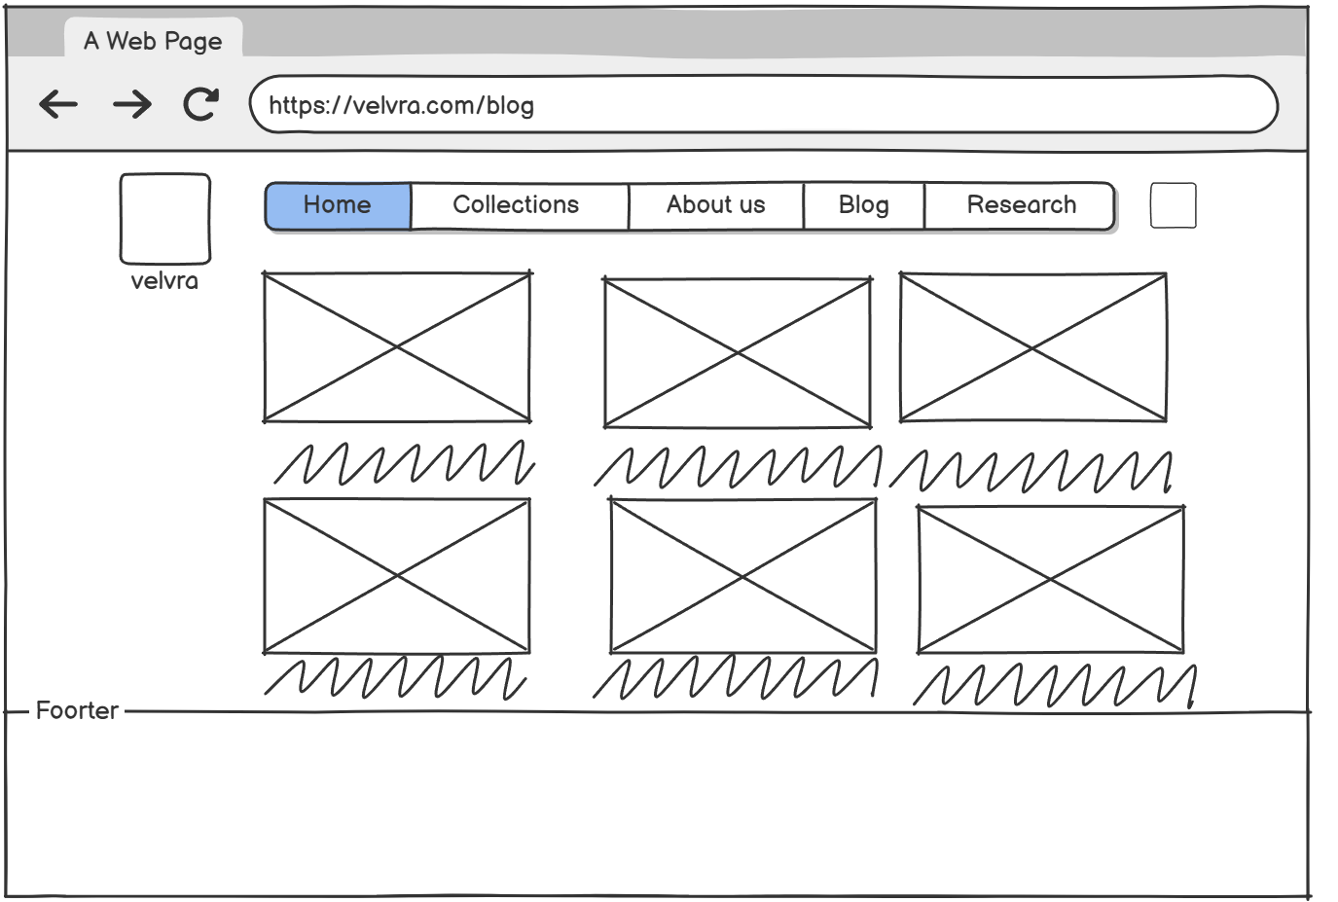We build a knowledgeable community of fashion customers through periodic blog updates with enriched researched content. The blog harmonically supports the shopping experience while expressing Velvra’s unique combination of fashion and comfort and innovation values. For users seeking styling recommendations or information about different shoes that they wear the Blog Page provides both valuable inspiration and informative content.

Figure 17 Wireframe of Blog Page

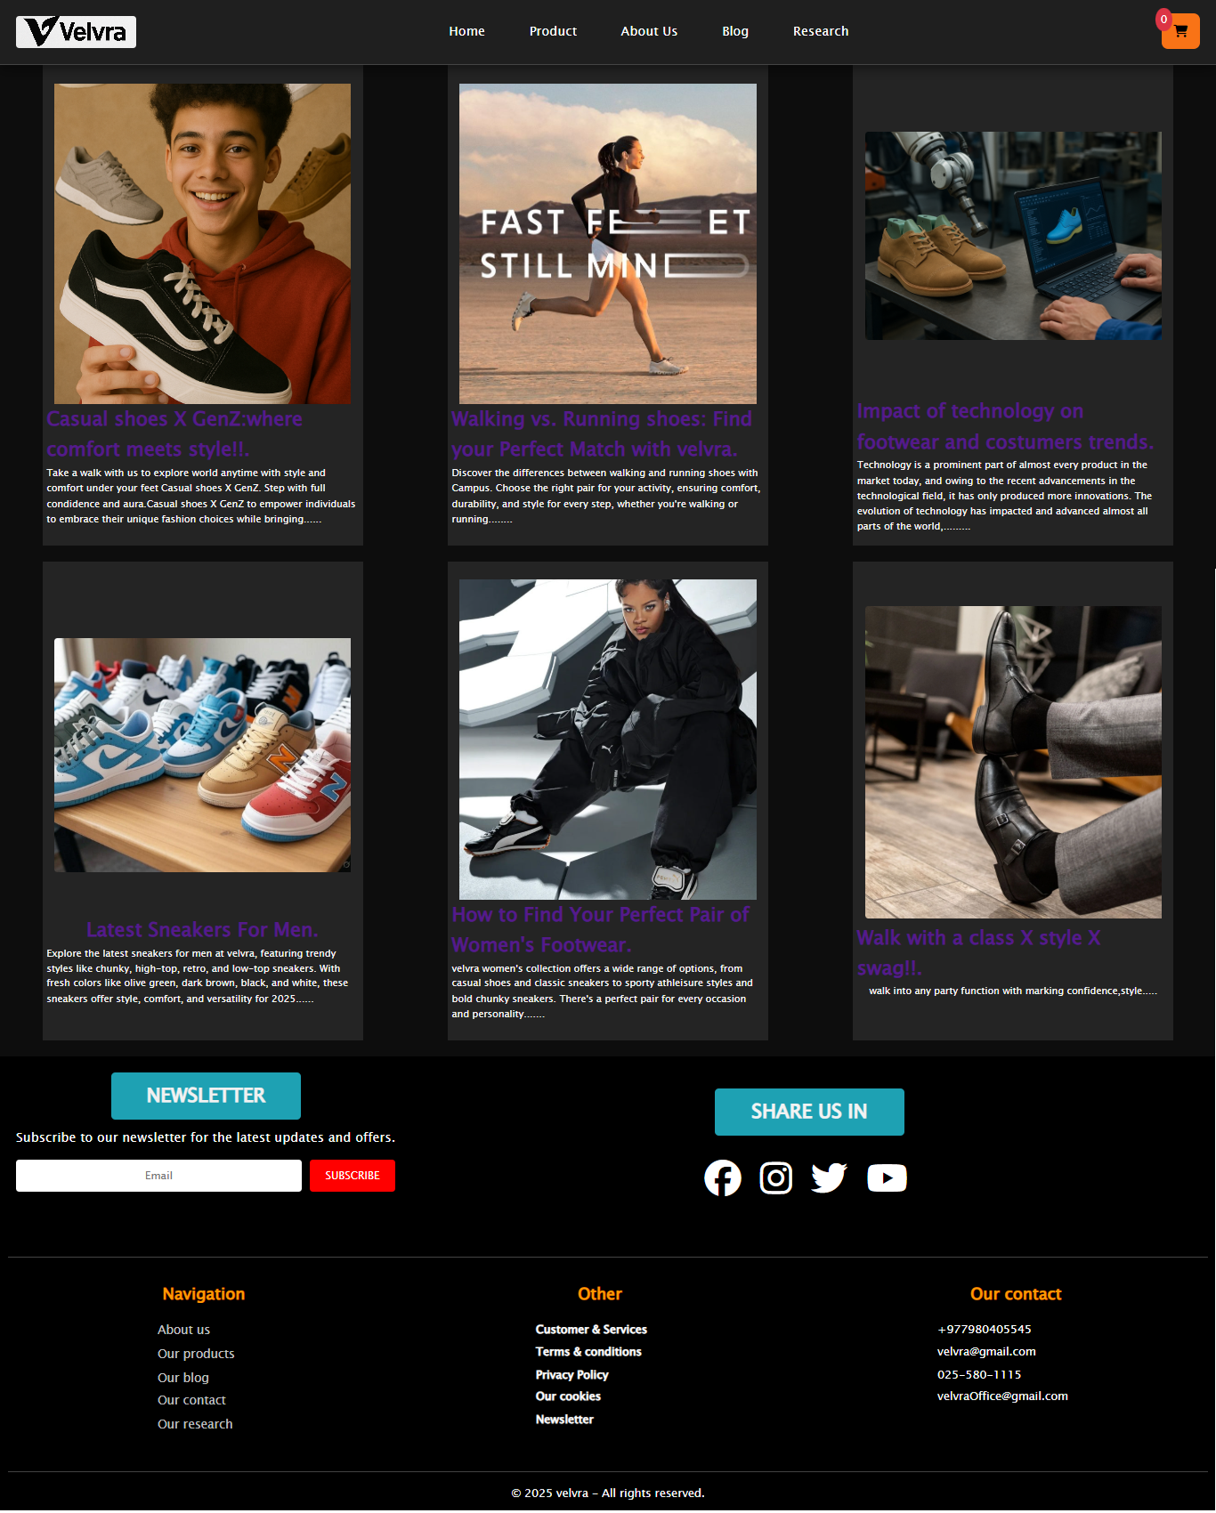

Figure 18 Blog Page

### Research Page

The Research Page of our website offers shows the creating process of our online ecommerce website. This page shows what different tool and technology help us to transform academic understanding into practical.

Our Research Page describes language like HTML, CSS, and JavaScript we used. The page describes responsive design methods and layout and styling method that help users experience dynamic and smooth perfomance.

During development, we noted every step starting from planning through wireframing and designing, testing. We provide access to references and learning resources such as tutorials, documentation, and online learning materials that enabled our education and implementation process.

The Research Page highlights our dedication to ongoing development combined with collective efforts and open operations. This page displays our engineering expertise while highlighting useful instruction for budding web developers. By using this page we want to tell our story of learning together and show the resources that played an essential role in our project.

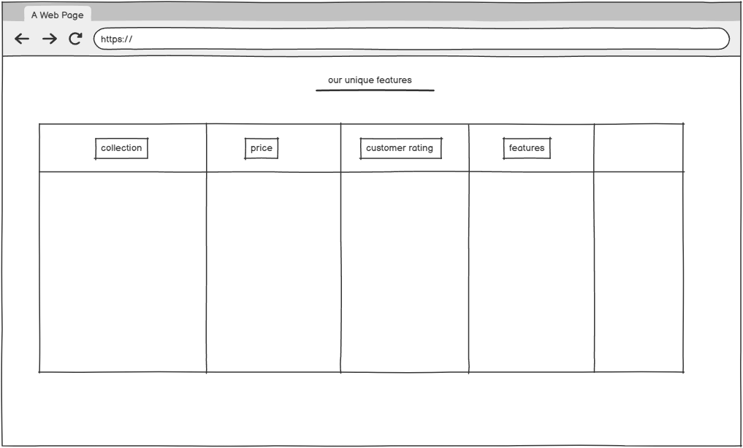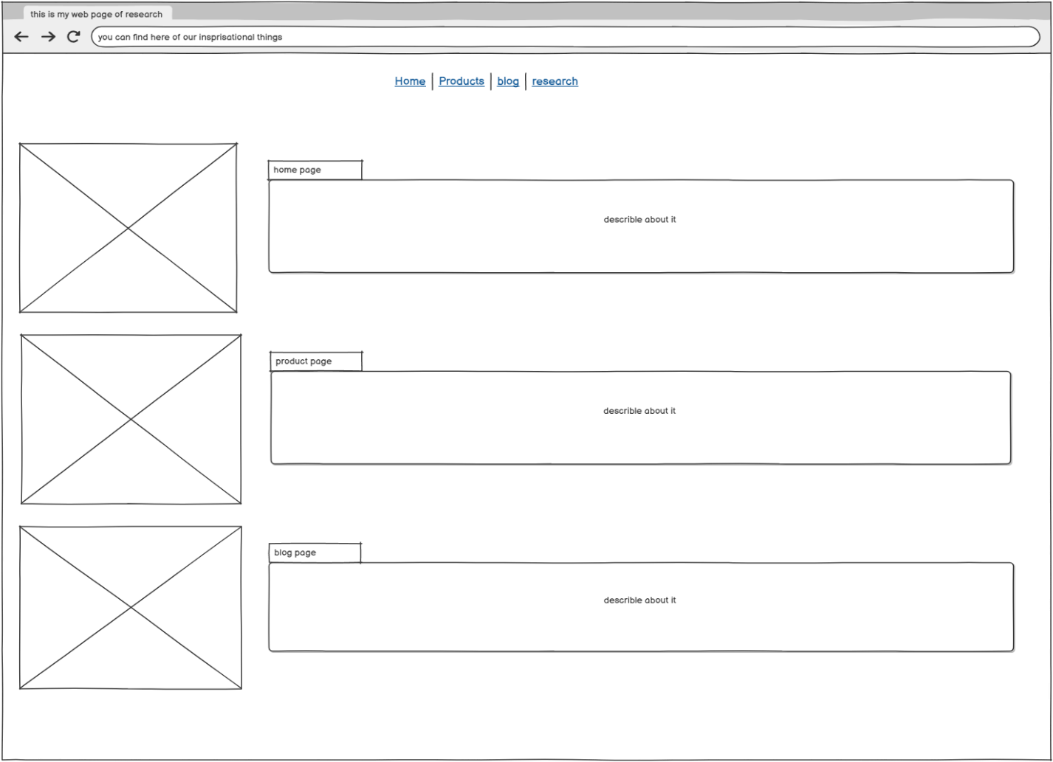

Figure 19Wireframe Of Research Page

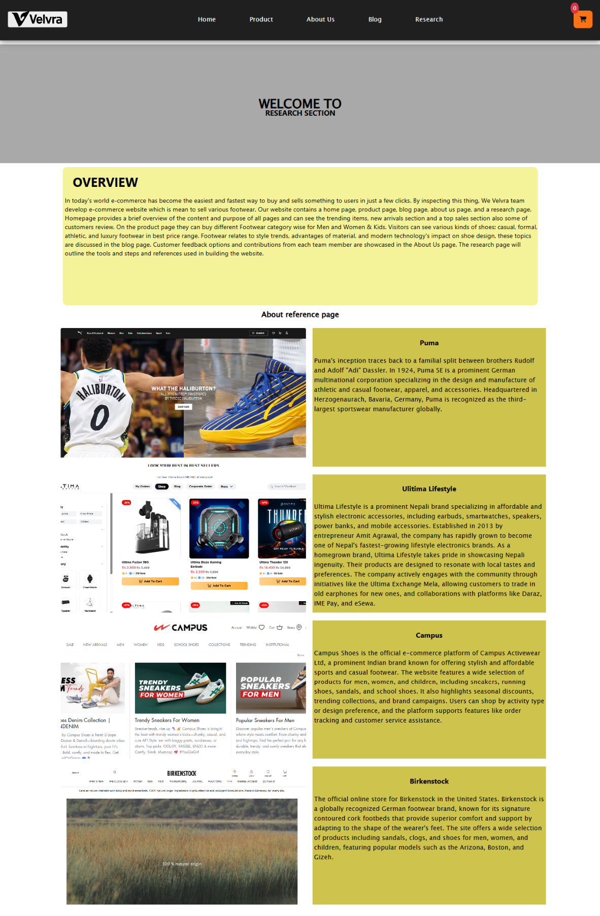

Figure 20 Research Page

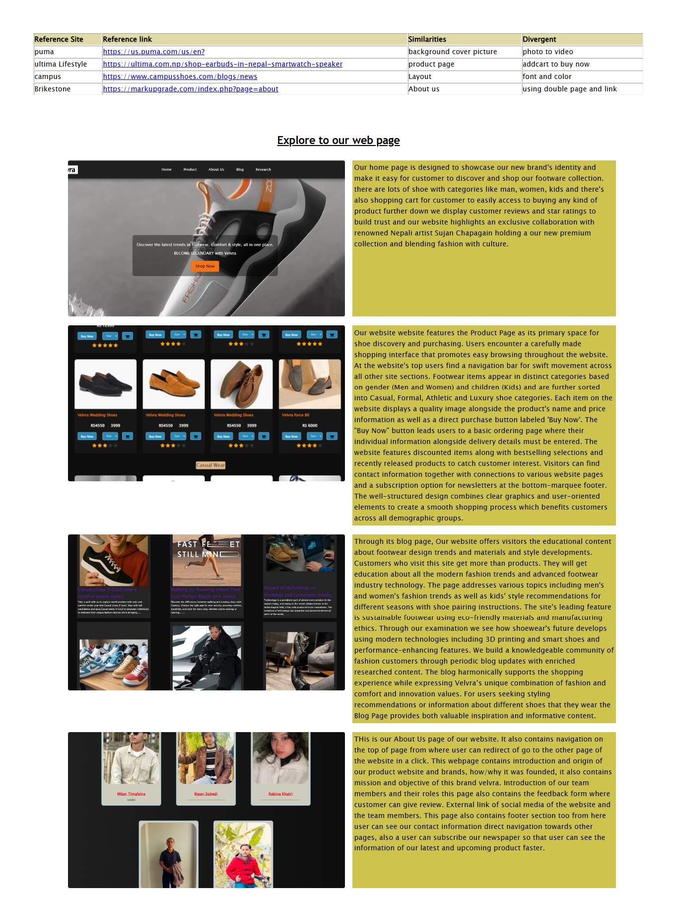

Figure 21 Research Page

# Testing

### 3.1 Test 1 Checking the item add to cart

|  |  |
| --- | --- |
| Objective | Checking the add to cart |
| Action | Clicking the add to cart in a product |
| Expected result | Alert message name added to cart successfully of price |
| Actual result | Message alerted |
| Conclusion | Test successful |

Table 1 Checking the item add to cart

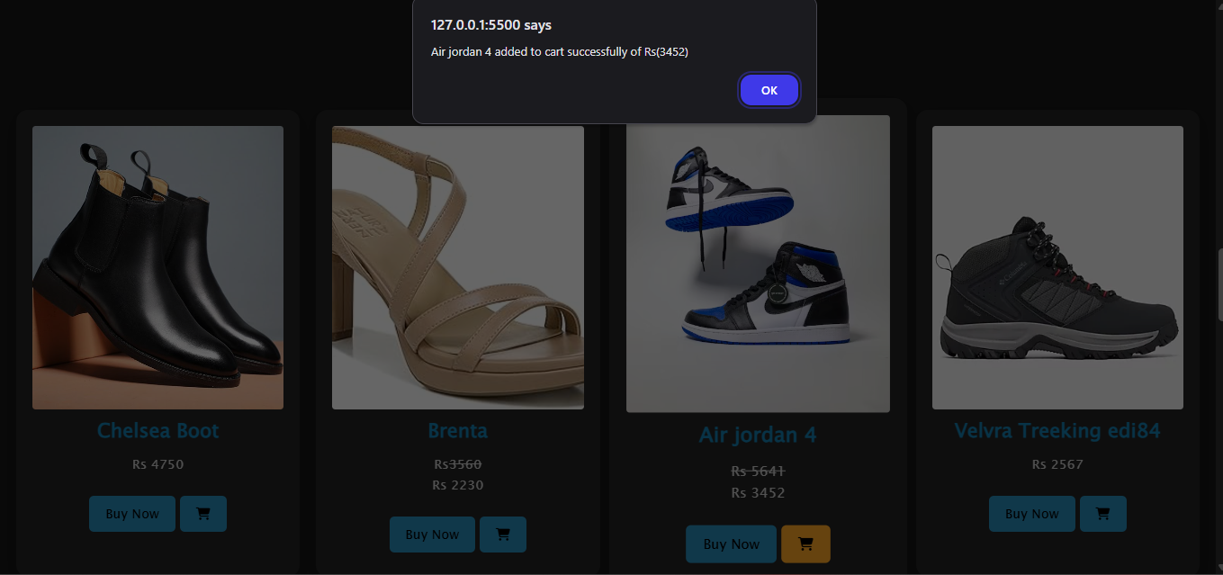

Figure 22Test 1 Checking the item add to cart

### 3.2 Test 2 Checking navbar hover effect

|  |  |
| --- | --- |
| Objective | Checking navbar hover effect |
| Action | Moving the mouse in the nav button |
| Expected result | Hover effect occurs in the nav button |
| Actual result | Hover effect occurred |
| Conclusion | Test successful |

Table 2 Checking navbar hover effect

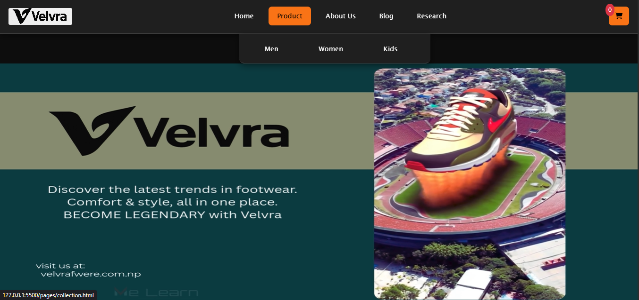

Figure 23 Navbar hover effect

### 3.3 Test 3 checking newsletter subscription

|  |  |
| --- | --- |
| Objective | Checking newsletter subscription |
| Action | Subscribe newsletter using email |
| Expected result | Alert message email Thank you for subscribing! |
| Actual result | Alerted email Thank you for subscribing! |
| Conclusion | Test successful |

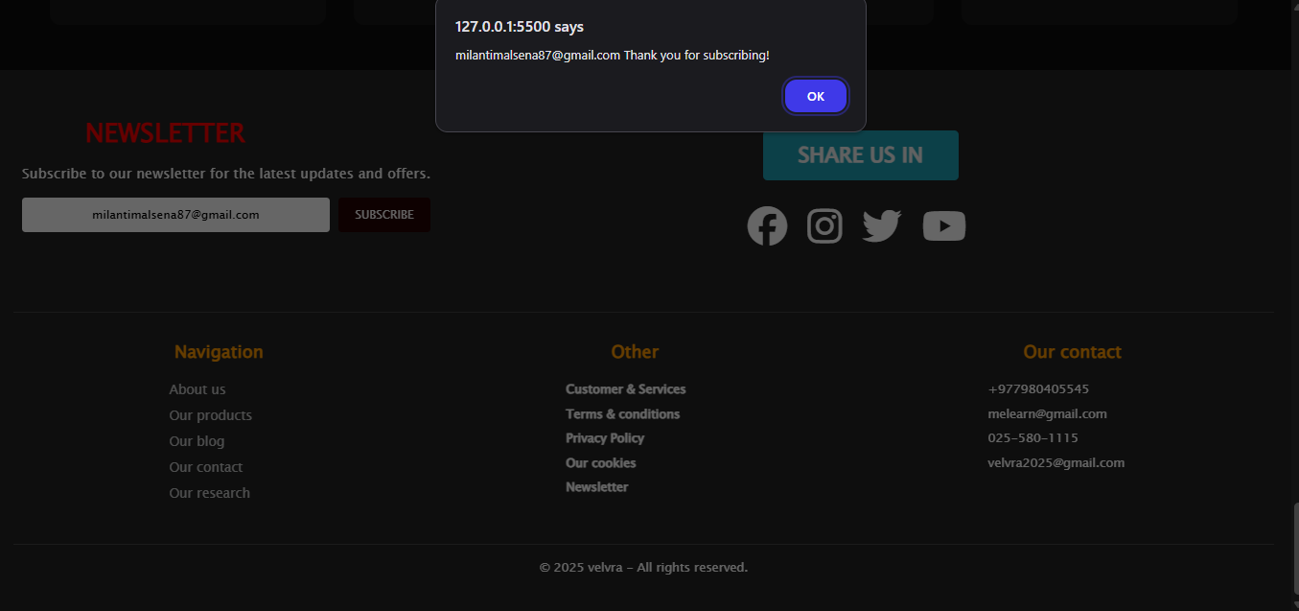Table 3 checking newsletter subscription

Figure 24 newsletter subscription

### 3.4 Test 4 checking internal link

|  |  |
| --- | --- |
| Objective | Checking the internal link. |
| Action | Clicking the button. |
| Expected result | To move to other page. |
| Actual result | Moved to other page. |
| Conclusion | Test successful. |

Table 4 checking internal link

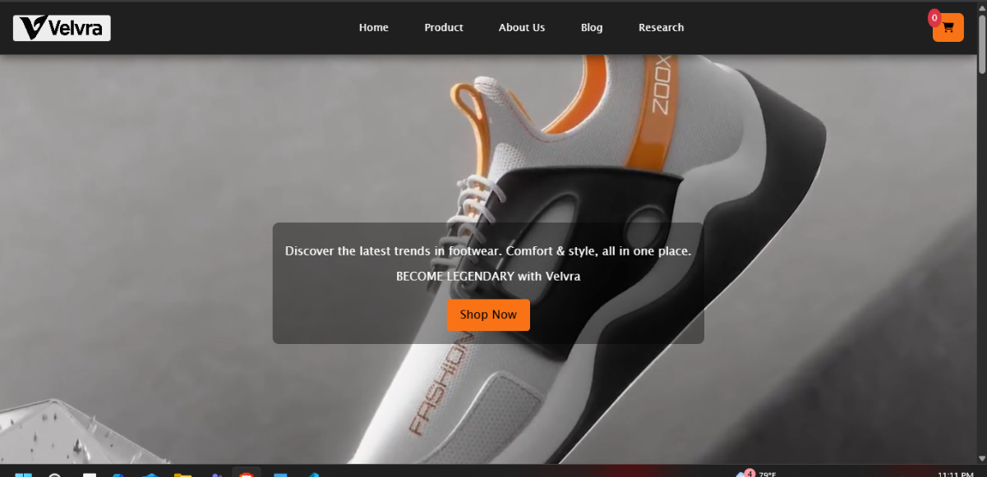

Figure 25 checking internal link

### 3.5 Test 5 Checking external link

|  |  |
| --- | --- |
| Objective | Checking the external Link |
| Action | Clicking the icon |
| Expected result | Redirect to their respective social media accounts |
| Actual result | Moved to their account. |
| Conclusion | Test successful |

Table 5 Checking external link

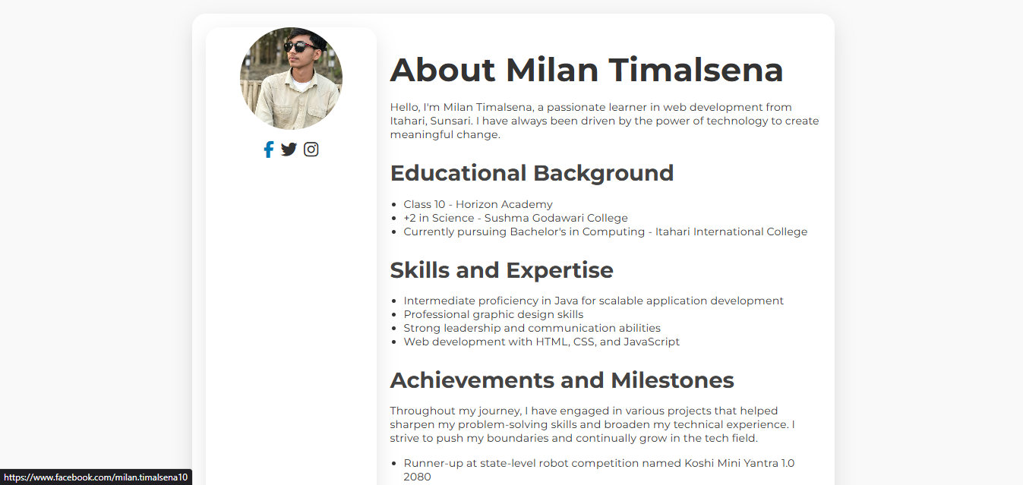

Figure 26 Checking external link

### 3.6 Test 6 Checking order completion Message

|  |  |
| --- | --- |
| Objective | Checking order completion Message |
| Action | Submitting the order form. |
| Expected result | Message Dear, Name your order for address has been placed successfully! |
| Actual result | Message popup |
| Conclusion | Test Successful |

Table 6 Checking order completion Message

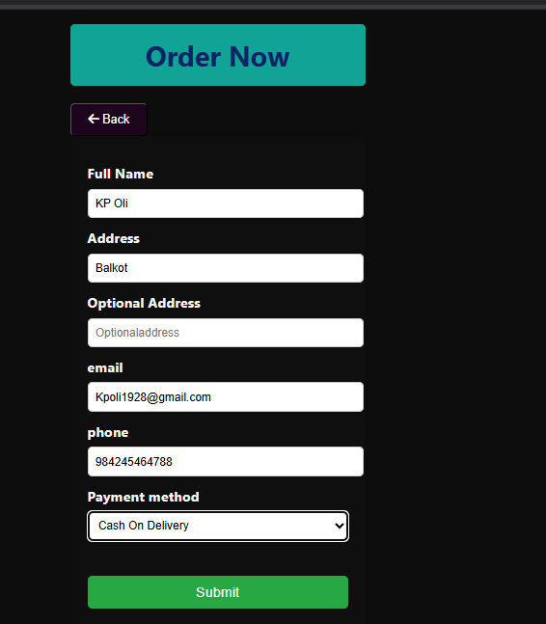

Figure 27 Entering details in order form

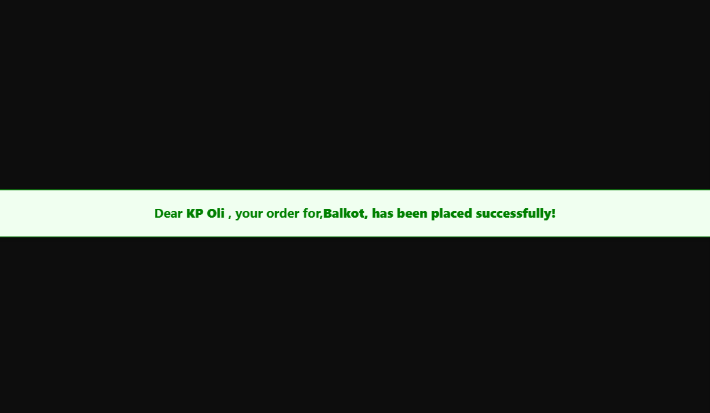

Figure 28 Order message displayed successfully

# Tags used

In Html we use different tags according to needs among them some are described below which I used in my project.

### 4.1 div Tag

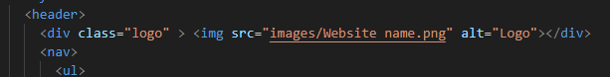The div tag is used here to separate the logo from the header which is in head section but we can edit it in CSS as our need individually only logo no any other elements present in header will changed we adjusted the height, width, margin padding, color, etc. separately here this is used in every webpages of our website.

Figure 29 Example of div tag used in Home page

### 4.2 meta tag



Figure 30 Meta Tag

The meta tag is used in the HTML to provides the information of website or webpages which is not seen to user but can be useful for search engines.

### 4.3 img tag

Figure 31 img tag

This img tag is used to insert the image from the device or storage which is saved in same folder where we are working. In above picture I used img tag to add the picture named s5 which is under images folder of the folder where we are working. And alt describe alternative if the image is not shown to the some users then the alt section will run and shows the alt text.

### 4.4 form tag

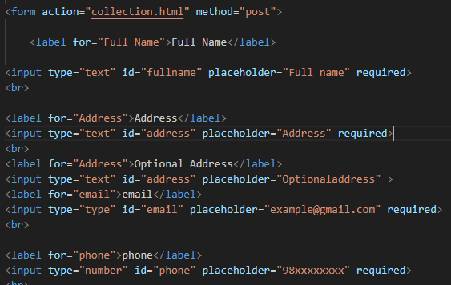

The form tag is used to create a form which users should fill and the user input is collected by the developer. In above form I created a form tag to place a costumer order once customer click on buy something online then the user should fills the some details of their own like name, address, phone, email, payment method and the user order is placed automatically.

# CSS Types

### 5.1 Inline CSS

Inline CSS is a method of applying CSS/ styling directly to HTML elements using the style attribute inside the same tag. This Inline CSS prioritize more than external and internal stylesheet. we’ve also used it in different tags for different styling like color align and many more one of the example of it is pasted below.



Figure 32 Inline CSS

### 5.2 Internal CSS

An internal CSS represents a way to declare CSS styles inside an HTML file by placing them inside the <style> tag located in the <head> section of the document.

This method allows you to apply distinctive styles to a single webpage and simplifies style management on that particular page.

Using internal CSS for multiple web pages causes time consumption because each web page requires you to put CSS specifications in its own page.

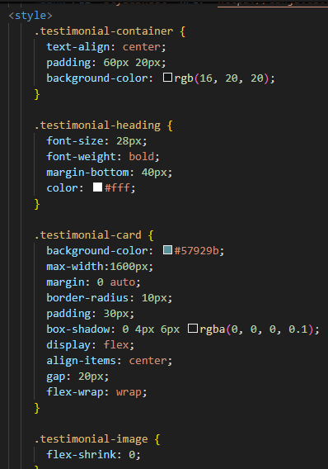This Inline CSS prioritize more than external and less than inline stylesheet. we’ve also used it in our web development.

Figure 33 Internal CSS

### 5.3 External CSS

The method of styling these web pages with only one stylesheet called external CSS creates a common structure for both HTML pages to reflect their distinct design elements. We have used navbar.css and foot.css to link every page of our website. we have done in separate style sheets by saving CSS information into standalone files with the . The style properties written inside the CSS file apply to different HTML elements including the classes and IDs and headings.

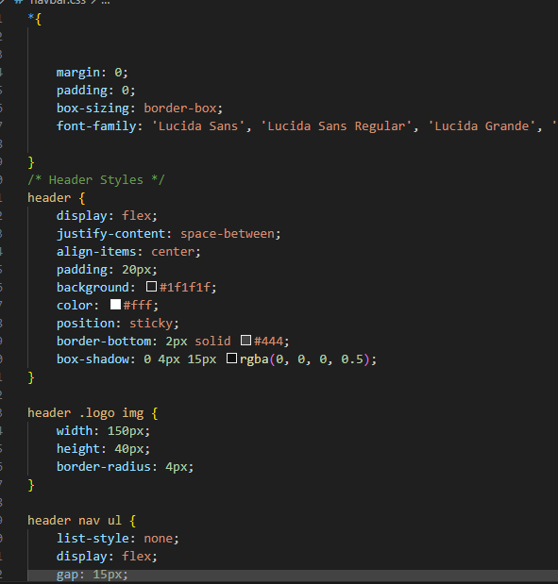

Figure 34E external CSS

# Conclusion

For this Coursework, we’ve made an e-commerce website using tools like HTML, CSS and JavaScript where we made a proper functional, user friendly website, here user can buy a various footwear in just few clicks. Me and my team are worried about this first but later on our Module lecturer and Tutor gave us a good idea which we implement in our website, also we research from various sources individually and as a group too. By this our research skills have improved a lot. During this coursework our team work ability and coordination on team has build somehow. This coursework helps us to gain the skills and problem solving skills like how to tackle the specific problem. Now we can develop the similar webpages and website in future very well by not repeating the same mistakes we did this time.

Our websites have 5 main webpages, which is developed by different team members, Milan Timalsena developed a Home page and Product page including their respective wireframes, Krishman Subedi developed a Women section of product page, Rabina Khatri developed an About us page and its wireframe, Sumit Dhakal developed a Research page and its wireframe and Bipan Subedi developed a Blog page of our website and its wireframe. And each team member has equal contribution in documentation.

Through this coursework we’ve learned a frontend development. Designing the wireframe and proper use of HTML to design the website , CSS to make our website good looking and JavaScript to make our website dynamic.

We have faced many challenges during this coursework. Initially, our team faced many challenges however, with guidance of module lecturer and tutor, and collaborative research of both individually and as a group. we were able to successfully implement our ideas into the website.

This coursework could have even better if we add the backend on it and secure payment gateway, filtering the product according to price range and by name.

In conclusion, though it was tough, we have gain much experience and proper use of tags and CSS as well as JS and understood it better.

# References

* Balsamiq 2017. Introduction to Balsamiq Wireframes for Desktop.   
  [Online] available at: <https://balsamiq.com/learn/ui-control-guidelines/links/>
* Font awesome 2017. Icon designing platform. Available at: <https://fontawesome.com/v4/icons>
* W3schools. Learning platform with tutorial and slides. Available at:<https://www.w3schools.com/>

# Appendix

### 8.1 Home Page HTML

<!DOCTYPE html>

<html lang="en">

<head>

<meta charset="UTF-8">

<meta name="viewport" content="width=device-width, initial-scale=1.0">

<title>Velvra| Home</title>

<link rel="icon" type="image/jpg" href="../images/icon.jpg" sizes="16x16">

<link rel="stylesheet" href="../css/navbar.css">

<link rel="stylesheet" href="../css/index.css">

<link rel="stylesheet" href="../css/foot.css">

<link rel="stylesheet" href="https://cdnjs.cloudflare.com/ajax/libs/font-awesome/6.7.2/css/all.min.css">

<style>

.testimonial-container {

text-align: center;

padding: 60px 20px;

background-color: rgb(16, 20, 20);

}

.testimonial-heading {

font-size: 28px;

font-weight: bold;

margin-bottom: 40px;

color: #fff;

}

.testimonial-card {

background-color: #57929b;

max-width:1600px;

margin: 0 auto;

border-radius: 10px;

padding: 30px;

box-shadow: 0 4px 6px rgba(0, 0, 0, 0.1);

display: flex;

align-items: center;

gap: 20px;

flex-wrap: wrap;

}

.testimonial-image {

flex-shrink: 0;

}

.testimonial-image img {

width: 250px;

height: 250px;

object-fit: cover;

border-radius: 50%;

border: 5px solid #fff;

}

.testimonial-content {

flex: 1;

text-align: left;

}

.testimonial-name {

font-size: 20px;

font-weight: bold;

margin-bottom: 5px;

}

.stars {

color: orange;

margin-bottom: 10px;

}

.testimonial-text {

font-size: 14px;

color: #333;

margin-bottom: 15px;

}

.see-more-btn {

display: inline-block;

background-color: orange;

color: white;

padding: 8px 16px;

text-decoration: none;

border-radius: 4px;

font-weight: bold;

}

</style>

</head>

<body>

<!-- Navigation Bar -->

<header>

<div class="logo" > <img src="../images/Website name.png" alt=""></div>

<nav>

<ul>

<li><a href="../pages/index.html">Home</a></li>

<li><a href="../pages/collection.html">Product</a></li>

<li><a href="../pages/About us.html">About Us</a></li>

<li><a href="../pages/blog.html">Blog</a></li>

<li><a href="../pages/research.html">Research</a></li>

</ul>

</nav>

<div class="header-actions">

<a href="#" class="cart-btn">

<i class="fa-solid fa-cart-shopping"></i>

<span class="cart-count">0</span>

</a>

</div>

</header>

<!-- Hero Section -->

<div class="hero">

<div class="hero-content">

<video autoplay muted loop class="background-clip">

<source src="../video/home page background cover.mp4" type="video/mp4">

</video>

<h1></h1>

<p>Discover the latest trends in footwear. Comfort & style, all in one place.</p>

<p>BECOME LEGENDARY with Velvra</p>

<a href="../pages/collection.html" class="shop-now">Shop Now</a>

</div>

</div>

<!-- Product Showcase -->

<div class="products">

<h2 style="color: rgb(243, 239, 239);" > <u>Trending Shoes</u></h2>

<div class="product-grid">

<div class="product">

<img src="../images/ath 2.avif" alt="Running Shoes">

<h3>Running Shoes</h3>

<p>Rs 4654</p>

<a href="../pages/order.html"><button class="buy">Buy Now</button></a>

<button class="addtocart"><i class="fa-solid fa-cart-shopping" id="cart"></i></button>

</div>

<div class="product">

<img src="../images/b5.webp" alt="Casual Sneakers">

<h3>Casual SneakeRs</h3>

<p>Rs<del>5720</del><br>Rs 3456</p>

<a href="../pages/order.html"><button class="buy">Buy Now</button></a>

<button class="addtocart"><i class="fa-solid fa-cart-shopping" id="cart"></i></button>

</div>

<div class="product">

<img src="../images/s2.avif" alt="Sports Shoes">

<h3>Sports Shoes</h3>

<p>Rs 5360</p>

<a href="order.html"><button class="buy">Buy Now</button></a>

<button class="addtocart"><i class="fa-solid fa-cart-shopping" id="cart"></i></button>

</div>

</div>

<section class="promotion">

<div class="promotion-content">

<p>Sujan Chapagain</p>

<a href="../pages/collection.html" class="shop-now">Shop Now</a>

</div>

</section>

<!--Best sellings-->

</div>

<div class="bestsellings">

<h2 style="color: rgb(241, 237, 237);" > <u>Best Sellings</u></h2>

<div class="arrival-grid">

<div class="sellings">

<img src="../images/formal 1.jpg" alt="Running Shoes">

<h3>Chelsea Boot</h3>

<p>Rs 4750</p>

<a href="../pages/order.html"><button class="buy">Buy Now</button></a>

<button class="addtocart"><i class="fa-solid fa-cart-shopping" id="cart"></i></button>

</div>

<div class="sellings">

<img src="../images/women 2.jpg" alt="ankle boots">

<h3>Brenta</h3>

<p>Rs<del>3560</del><br>Rs 2230</p>

<a href="../pages/order.html"><button class="buy">Buy Now</button></a>

<button class="addtocart"><i class="fa-solid fa-cart-shopping" id="cart"></i></button>

</div>

<div class="sellings">

<img src="../images/s9.avif" alt="Sports Shoes">

<h3>Air jordan 4</h3>

<p><del>Rs 5641</del> <br>Rs 3452</p>

<a href="../pages/order.html"><button class="buy">Buy Now</button></a>

<button class="addtocart"><i class="fa-solid fa-cart-shopping" id="cart"></i></button>

</div>

<div class="sellings">

<img src="../images/ath 4.webp" alt="Sports Shoes">

<h3>Velvra Treeking edi84</h3>

<p>Rs 2567</p>

<a href="../pages/order.html"><button class="buy">Buy Now</button></a>

<button class="addtocart"><i class="fa-solid fa-cart-shopping" id="cart"></i></button>

</div>

</div>

</div>

<!-- new arrivals -->

<div class="arrivals">

<h2 style="color: rgb(245, 242, 242);" > <u>New Arrivals</u></h2>

<div class="arrival-grid">

<div class="arrival">

<img src="../images/women 5.jpg" alt="Running Shoes">

<h3> Ankle Boots</h3>

<p>Rs 2579</p>

<a href="../pages/order.html"><button class="buy">Buy Now</button></a>

<button class="addtocart"><i class="fa-solid fa-cart-shopping" id="cart"></i></button>

</div>

<div class="arrival">

<img src="../images/f2.jpg" alt="Running Shoes">

<h3>Velvra scott 78</h3>

<p>Rs 9999</p>

<a href="../pages/order.html"><button class="buy">Buy Now</button></a>

<button class="addtocart"><i class="fa-solid fa-cart-shopping" id="cart"></i></button>

</div>

<div class="arrival">

<img src="../images/ath 3.png" alt="Casual Sneakers">

<h3>Velvra Football v45</h3>

<p>Rs 2567</p>

<a href="../pages/order.html"><button class="buy">Buy Now</button></a>

<button class="addtocart"><i class="fa-solid fa-cart-shopping" id="cart"></i></button>

</div>

<div class="arrival">

<img src="../images/formal 2.jpg" alt="Sports Shoes">

<h3>Oxford Shoes</h3>

<p>Rs<del>10255</del> <br>Rs 7999</p>

<a href="../pages/order.html"><button class="buy">Buy Now</button></a>

<button class="addtocart"><i class="fa-solid fa-cart-shopping" id="cart"></i></button>

</div>

</div>

</div>

<div class="testimonial-container">

<div class="testimonial-heading">WHAT OUR HAPPY CLIENT SAYS?</div>

<div class="testimonial-card">

<div class="testimonial-image">

<img src="../images/kpoli.webp" alt="Client Image" />

</div>

<div class="testimonial-content">

<div class="testimonial-name">KP Oli</div>

<div class="stars" style="font-size: 30px;">★★★★★</div>

<div class="testimonial-text">

“I’m absolutely impressed with my new pair of shoes! The comfort, stylish design, and outstanding build quality went beyond my expectations. From browsing the easy-to-navigate website to the prompt delivery and premium packaging, every step of the process was seamless. I’ll definitely recommend this brand to friends and family!”<br>

Thank you for the amazing service! <strong>VELVRA</strong>.

</div>

<a href="#" class="see-more-btn">SEE MORE</a>

</div>

</div>

</div>

<div class="testimonial-card">

<div class="testimonial-image">

<img src="../images/leo messi.webp" alt="Client Image" />

</div>

<div class="testimonial-content">

<div class="testimonial-name">Lional Messi</div>

<div class="stars" style="font-size: 30px;">★★★★★</div>

<div class="testimonial-text">

"As someone who's been on the pitch for decades,

I know how important the right boots are.

I recently picked up a pair from this store,

and I have to say, they’ve got it spot on.

The fit is perfect, the grip is flawless,

and the design makes every touch feel magical. Whether

I’m dancing past defenders or striking for goal,

these boots never let me down. Thanks for the amazing service <strong>Velvra</strong>– you’ve earned my trust. Looking forward to my next pair!"

</div>

<a href="#" class="see-more-btn">SEE MORE</a>

</div>

</div>

<!-- Footer -->

<footer>

<div class="footer1">

<form>

<div class="newsletter">

<div class="heading1">

<h1>NEWSLETTER</h1>

<p>Subscribe to our newsletter for the latest updates and offers.</p>

</div>

<div class="userInput">

<input

type="email"

placeholder="Email"

style="text-align: center"

required >

<button id="Subscribe" type="button">SUBSCRIBE</button>

</div>

</div>

</form>

<div class="shareus">

<div class="heading2">

<h3>SHARE US IN</h3>

</div>

<div class="links">

<a href=""> <i class="fa-brands fa-facebook"></i> </a>

<a href="#instagram"> <i class="fa-brands fa-instagram"></i> </a>

<a href="#twitter"> <i class="fa-brands fa-twitter"></i> </a>

<a href="#youtube"> <i class="fa-brands fa-youtube"></i></a>

</div>

</div>

</div>

<div class="footer2">

<div class="navlinks">

<div class="headings">

<h2 style="padding-left: 10px">Navigation</h2>

<h2 style="padding-left: 50px">Other</h2>

<h2 style="margin-left: 70px">Our contact</h2>

</div>

<div class="mainitems">

<div class="items" id="1">

<p><a href="../pages/About us.html">About us</a></p>

<p><a href="../pages/collection.html">Our products</a></p>

<p><a href="../pages/blog.html">Our blog</a></p>

<p><a href="../pages/Ourteam/Ourteam.html">Our contact</a></p>

<p><a href="../pages/research.html">Our research</a></p>

</div>

<div class="items" id="2">

<h4>Customer & Services</h4>

<h4>Terms & conditions</h4>

<h4>Privacy Policy</h4>

<h4>Our cookies</h4>

<h4>Newsletter</h4>

</div>

<div class="items" id="contact">

<p>+977980405545</p>

<p>melearn@gmail.com</p>

<p>025-580-1115</p>

<p>velvra2025@gmail.com</p>

<p></p>

</div>

</div>

</div>

<div class="copyright">

<p>&copy; 2025 Velvra - All rights reserved.</p>

</div>

</div>

</footer>

<script>

// Handle Add to Cart button clicks

const addToCartButtons = document.querySelectorAll('.addtocart');

addToCartButtons.forEach(button => {

button.addEventListener('click', function() {

const productElement = this.closest('.product, .sellings, .arrival');

const itemName = productElement.querySelector('h3').innerText;

// Check for discounted price (if a <del> tag exists)

const delPrice = productElement.querySelector('p del');

let itemPrice;

if (delPrice) {

// Use the discounted price if present, ignore the original

itemPrice = productElement.querySelector('p').innerText.split('\n').slice(-1)[0].replace(/[^0-9]/g, '');

} else {

// Use the regular price if no discount

itemPrice = productElement.querySelector('p').innerText.replace(/[^0-9]/g, '');

}

addToCart(itemName, itemPrice);

});

});

// Add to cart function

function addToCart(itemName, itemPrice) {

alert(`${itemName} added to cart successfully of Rs(${itemPrice})`);

// Additional cart logic can go here, like updating a cart icon or storing in localStorage

}

</script>

<script src="../js/newsletter.js">

</script>

</body>

</html>

### 8.2 Home Page CSS

* {

margin: 0;

padding: 0;

box-sizing: border-box;

}

body {

font-family: 'Segoe UI', Tahoma, Geneva, Verdana, sans-serif;

background-color: beige;

color: #f5f5f5;

line-height: 1.6;

}

/* Hero Section */

.hero {

height: 99vh;

display: flex;

justify-content: center;

align-items: center;

color: white;

text-align: center;

}

.hero-content {

background: rgba(0, 0, 0, 0.4);

padding: 20px;

border-radius: 10px;

}

.background-clip{

position: absolute;

right: 0;

left: 0;

top: 10%;

bottom: 0;

object-fit:cover;

z-index: -1;

height:auto;

}

@media(min-aspect-ratio: 16/9){

.background-clip{

width: 100%;

height: auto;

}

}

.hero h1 {

font-size: 50px;

margin: 0;

}

.hero p {

font-size: 18px;

margin: 10px 0;

}

.shop-now {

background-color: #f97316;

color: black;

padding: 10px 20px;

text-decoration: none;

font-size: 18px;

display: inline-block;

margin-top: 10px;

border-radius: 5px;

}

.shop-now:hover{

background-color: rgb(180, 154, 122);

color: #8d0f0f;

}

/* Product Section Styles */

.products, .bestsellings, .arrivals {

padding: 40px 20px;

background: #161616;

}

.products h2, .bestsellings h2, .arrivals h2 {

color: #f97316;

font-size: 2.5rem;

text-align: center;

margin-bottom: 40px;

}

.product-grid, .arrival-grid {

display: grid;

grid-template-columns: repeat(auto-fit, minmax(280px, 1fr));

gap: 20px;

}

.product, .sellings, .arrival {

background: #242424;

border-radius: 15px;

padding: 20px;

box-shadow: 0 8px 20px rgba(0, 0, 0, 0.15);

text-align: center;

transition: transform 0.3s ease, box-shadow 0.3s ease;

}

.product:hover, .sellings:hover, .arrival:hover {

transform: scale(1.05);

box-shadow: 0 12px 25px rgba(0, 0, 0, 0.2);

}

.product h3, .sellings h3, .arrival h3 {

color: #147fb1;

font-size: 1.5rem;

margin-bottom: 10px;

}

.product p, .sellings p, .arrival p {

color: #ccc;

margin-bottom: 15px;

}

.buy, .addtocart {

background: #288bb9;

color: #000;

padding: 10px 20px;

border-radius: 6px;

font-size: 1rem;

transition: background 0.3s ease, color 0.3s ease;

border: none;

cursor: pointer;

}

.buy{

margin-right: 30px;

}

.addtocart{

margin-left: 30px;

}

.buy:hover, .addtocart:hover {

background: #ffa726;

color: #000;

}

.promotion{

height: 99vh;

margin-top: 40px;

background: url('../images/promotion\ cover.png') no-repeat center center/cover;

display: flex;

justify-content: center;

align-items: center;

color: white;

text-align: center;

}

.promotion-content {

margin-top: 31%;

margin-right: 17%;

padding: 20px;

border-radius: 10px;

}

.promotion h1 {

font-size: 50px;

margin: 0;

}

.promotion p {

font-size: 18px;

margin: 10px 0;

}

### 8.3 Navbar CSS

*{

margin: 0;

padding: 0;

box-sizing: border-box;

font-family: 'Lucida Sans', 'Lucida Sans Regular', 'Lucida Grande', 'Lucida Sans Unicode', Geneva, Verdana, sans-serif;

}

/* Header Styles */

header {

display: flex;

justify-content: space-between;

align-items: center;

padding: 20px;

background: #1f1f1f;

color: #fff;

position: sticky;

border-bottom: 2px solid #444;

box-shadow: 0 4px 15px rgba(0, 0, 0, 0.5);

}

header .logo img {

width: 150px;

height: 40px;

border-radius: 4px;

}

header nav ul {

list-style: none;

display: flex;

gap: 15px;

}

header nav ul li a {

color: #fff;

text-decoration: none;

font-size: 1rem;

padding: 10px 20px;

border-radius: 8px;

}

header nav ul li a:hover {

background: #f97316;

color: #000;

}

header .cart-btn {

background: #f97316;

color: #000;

border: none;

padding: 10px 15px;

cursor: pointer;

border-radius: 8px;

}

header .cart-btn:hover {

background: #ffa726;

color: #000;

}

.logo {

display: flex;

align-items: center;

margin: 0 ;

padding: 0;

}

.logo img {

width: 150px;

height: 40px;

border-radius: 4px;

}

img{

width: 100%;

height: 350px;

object-fit: cover;

border-radius: 4px;

}

/* Header Styles */

header {

display: flex;

justify-content: space-between;

align-items: center;

padding: 20px;

background: #1f1f1f;

color: #fff;

position: relative;

border-bottom: 2px solid #444;

box-shadow: 0 4px 15px rgba(0, 0, 0, 0.5);

}

header .logo img {

width: 150px;

height: 40px;

border-radius: 4px;

}

header nav ul {

list-style: none;

display: flex;

gap: 15px;

}

header nav ul li a {

color: #fff;

text-decoration: none;

font-size: 1rem;

padding: 10px 20px;

border-radius: 8px;

transition: background 0.3s ease;

}

header nav ul li a:hover {

background: #f97316;

color: #000;

}

header .cart-btn {

background: #f97316;

color: #000;

border: none;

padding: 10px 15px;

cursor: pointer;

border-radius: 8px;

transition: background 0.3s ease;

}

header .cart-btn:hover {

background: #ffa726;

color: #000;

}

.cart-count {

position: absolute;

margin-right: 20px;

top: 10px;

right: 35px;

background-color: #dc3545;

color: #fff;

border-radius: 50%;

padding: 4px 6px;

font-size: 0.8em;

}

header div img{

width: 105px;

height: 32px;

border-radius: 4px;

}

/* cart ko btn ma rang laideko */

/* Footer */

footer {

background: black;

color: white;

text-align: center;

padding: 10px;

margin-top: 20px;

}

.hed2{

display: flex;

justify-content: space-between;

align-items: center;

padding: 20px;

width: 30%;

height: 70px;

margin-left: 37.5%;

background: #1f1f1f;

color: #fff;

position: relative;

border-bottom: 2px solid #444;

box-shadow: 0 4px 15px rgba(0, 0, 0, 0.5);

border-bottom-right-radius: 12px;

border-bottom-left-radius: 12px;

}

.hed2 ul{

list-style: none;

display: flex;

gap: 15px;

}

.hed2 ul li{

display: inline-block;

justify-content: space-evenly;

align-items: center;

margin: 0 10px;

padding: 10px;

font-size: 20px;

color: #fff;

}

.hed2 ul li a{

color: #fff;

text-decoration: none;

font-size: 1rem;

padding: 10px 20px;

border-radius: 8px;

transition: background 0.3s ease;

}

.hed2 nav ul li a:hover {

background-color: #f97316;

color: #000;

}

### 8.4 Footer CSS

/* foot.css */

footer {

background-color: #222;

color: #fff;

padding: 40px 20px;

font-family: Arial, sans-serif;

}

/* Newsletter Section */

.footer1 {

display: flex;

flex-wrap: wrap;

justify-content: space-between;

align-items: flex-start;

border-bottom: 1px solid #444;

padding-bottom: 30px;

}

.newsletter {

flex: 1;

min-width: 250px;

margin: 10px;

}

.newsletter h1 {

font-size: 24px;

color: #ff0000;

text-decoration:double;

/* padding: 10px; */

font-size:30px;

border-radius: 5px;

height: auto;

width: 70%;

word-spacing: 30px;

border-radius: 5px;

margin-bottom: 10px;

}

.newsletter p {

margin-bottom: 15px;

}

.userInput {

display: flex;

gap: 10px;

}

.userInput input {

padding: 10px;

border: none;

border-radius: 4px;

flex: 1;

}

.userInput button {

padding: 10px 20px;

background-color: #ff0000;

color: #fff;

border: none;

border-radius: 4px;

cursor: pointer;

}

.userInput button:hover {

background-color: #240202;

}

/* Social Links */

.shareus {

flex: 1;

min-width: 200px;

margin: 10px;

text-align: center;

padding: 20px;

}

.shareus h3 {

font-size: 24px;

background-color: #1ea1b3;

padding: 10px;

border-radius: 5px;

height: auto;

width: 25%;

margin-left: 38%;

border-radius: 5px;

margin-bot00tom: 10px;

color: #f2f3f3;

}

.shareus h3 {

margin-bottom: 20px;

}

.links a {

color: #fff;

padding: 50px;

font-size: 45px;

text-decoration: none;

padding: 5px;

transition: color 0.3s ease;

}

.links a:hover {

color: #ff0077;

text-decoration: none;

}

/* Navigation Links */

.footer2 {

padding-top: 30px;

}

.navlinks {

display: flex;

flex-direction: column;

}

.headings {

display: flex;

justify-content: space-around;

margin-bottom: 10px;

}

.headings h2 {

font-size: 20px;

color: #ff9900;

}

.mainitems {

display: flex;

justify-content: space-around;

flex-wrap: wrap;

}

.items {

min-width: 180px;

margin-bottom: 20px;

}

.items p,

.items h4 {

margin: 6px 0;

font-size: 14px;

text-align: start;

color: #fff;

}

.items p{

font-size: 15px;

margin-left: 25px;

color: #fff;

padding-left: 2px;

}

.items p a {

color: #c1c3c4;

text-decoration: none;

}

.items p a:hover {

color: #ff0077;

text-decoration: underline;

}

.items a {

color: #fff;

text-decoration: none;

}

/* Contact Info */

#contact p {

word-wrap: break-word;

margin: 6px 0;

font-size: 14px;

}

/* Copyright */

.copyright {

text-align: center;

border-top: 1px solid #444;

padding-top: 15px;

font-size: 14px;

margin-top: 20px;

}

### 8.5 Product Page Html

<!DOCTYPE html>

<html lang="en">

<head>

<meta charset="UTF-8">

<meta name="viewport" content="width=device-width, initial-scale=1.0">

<title>Velvra| Collection</title>

<link rel="icon" type="image/jpg" href="../images/icon.jpg" sizes="16x16">

<link rel="stylesheet" href="../css/navbar.css">

<link rel="stylesheet" href="../css/collection.css">

<link rel="stylesheet" href="../css/foot.css">

<link rel="stylesheet" href="https://cdnjs.cloudflare.com/ajax/libs/font-awesome/6.7.2/css/all.min.css">

</head>

<body>

<!-- Navigation Bar -->

<header>

<div class="logo" > <img src="../images/Website name.png" alt=""></div>

<nav>

<ul>

<li><a href="../pages/index.html">Home</a></li>

<li><a href="../pages/collection.html">Product</a></li>

<li><a href="../pages/About us.html">About Us</a></li>

<li><a href="../pages/blog.html">Blog</a></li>

<li><a href="../pages/research.html">Research</a></li>

</ul>

</nav>

<div class="header-actions">

<a href="#" class="cart-btn">

<i class="fa-solid fa-cart-shopping"></i>

<span class="cart-count">0</span>

</a>

</div>

</header>

<section class=head2>

<div class="hed2">

<nav>

<ul>

<li><a href="../pages/collection.html">Men</a></li>

<li><a href="../pages/womencollection.html">Women</a></li>

<li><a href="#">Kids</a></li>

</ul>

</nav>

</div>

</section>

<div class="backgroundtop">

<video autoplay loop muted>

<source src="../video/background product cover velvra.mp4" type="video/mp4">

</video>

<div class="background-content">

</div>

</div>

<div style="margin-left: 42%;"><h2 style="display: flex; justify-content: center; align-items: center; background-color: rgb(212, 172, 119); width: 35%; border-radius: 5px; font-size: 30px;">Mens Collection</h2></div>

<br>

<br>

<div class="were" style="display:flex;justify-content: center ;align-items: center; background-color: burlywood; width: 16% ;margin-left: 42%; font-size: 25px;border-radius: 4px;">Formal/Party wear</div>

<div class="container">

<div class="item">

<a href="aligater.html">

<img src="../images/b7.jpg" alt=""class="mt">

<h4>Aligater leather boots</h4>

</a>

<h3>RS 12999</h3>

<div class="button-container">

<a href="../pages/order.html"><button class="buy">Buy Now</button></a>

<label for="size"></label>

<select name="size" id="size">

<option value="Sizeavailable">Size</option>

<option value="38">38</option>

<option value="39">39</option>

<option value="40">40</option>

<option value="41">41</option>

<option value="42">42</option>

<option value="43">43</option>

</select>

<button type="button" class="crt"><i class="fa-solid fa-cart-shopping" id="cart"></i></button>

</div>

<div class="rating">

<span class="fa fa-star checked"></span>

<span class="fa fa-star checked"></span>

<span class="fa fa-star checked"></span>

<span class="fa fa-star checked"></span>

<span class="fa fa-star checked"></span>

</div>

</div>

<div class="item">

<img src="../images/formal 1.jpg" alt=""class="mt">

<h4>Chelsea Boot</h4>

<h3>RS 7000</h3>

<div class="button-container">

<a href="../pages/order.html"><button class="buy">Buy Now</button></a>

<label for="size"></label>

<select name="size" id="size">

<option value="Sizeavailable">Size</option>

<option value="38">38</option>

<option value="39">39</option>

<option value="40">40</option>

<option value="41">41</option>

<option value="42">42</option>

<option value="43">43</option>

</select>

<button type="button" class="crt"><i class="fa-solid fa-cart-shopping" id="cart"></i></button>

</div>

<div class="rating">

<span class="fa fa-star checked"></span>

<span class="fa fa-star checked"></span>

<span class="fa fa-star checked"></span>

<span class="fa fa-star checked"></span>

<span class="fa fa-star"></span>

</div>

</div>

<div class="item">

<img src="../images/formal 2.jpg" alt=""class="mt">

<h4>Oxford Shoes </h4>

<h3>RS 8999</h3>

<div class="button-container">

<a href="../pages/order.html"><button class="buy">Buy Now</button></a>

<label for="size"></label>

<select name="size" id="size">

<option value="Sizeavailable">Size</option>

<option value="38">38</option>

<option value="39">39</option>

<option value="40">40</option>

<option value="41">41</option>

<option value="42">42</option>

<option value="43">43</option>

</select>

<button type="button" class="crt"><i class="fa-solid fa-cart-shopping" id="cart"></i></button>

</div>

<div class="rating">

<span class="fa fa-star checked"></span>

<span class="fa fa-star checked"></span>

<span class="fa fa-star checked"></span>

<span class="fa fa-star"></span>

<span class="fa fa-star"></span>

</div>

</div>

<div class="item">

<img src="../images/formal 3.jpg" alt="" class="mt">

<h4>Formal Party</h4>

<h3>RS 6999</h3>

<div class="button-container">

<a href="../pages/order.html"><button class="buy">Buy Now</button></a>

<label for="size"></label>

<select name="size" id="size">

<option value="Sizeavailable">Size</option>

<option value="38">38</option>

<option value="39">39</option>

<option value="40">40</option>

<option value="41">41</option>

<option value="42">42</option>

<option value="43">43</option>

</select>

<button type="button" class="crt"><i class="fa-solid fa-cart-shopping" id="cart"></i></button>

</div>

<div class="rating">

<span class="fa fa-star checked"></span>

<span class="fa fa-star checked"></span>

<span class="fa fa-star checked"></span>

<span class="fa fa-star checked"></span>

<span class="fa fa-star checked"></span>

</div>

</div>

<div class="item">

<img src="../images/f1.jpg" alt="" class="mt">

<h4>Velvra penny12</h4>

<h3>RS<del> 4550 </del> <p></p>3999</h3>

<div class="button-container">

<a href="../pages/order.html"><button class="buy">Buy Now</button></a>

<label for="size"></label>

<select name="size" id="size">

<option value="Sizeavailable">Size</option>

<option value="38">38</option>

<option value="39">39</option>

<option value="40">40</option>

<option value="41">41</option>

<option value="42">42</option>

<option value="43">43</option>

</select>

<button type="button" class="crt"><i class="fa-solid fa-cart-shopping" id="cart"></i></button>

</div>

<div class="rating">

<span class="fa fa-star checked"></span>

<span class="fa fa-star checked"></span>

<span class="fa fa-star checked"></span>

<span class="fa fa-star"></span>

<span class="fa fa-star"></span>

</div>

</div>

<div class="item">

<img src="../images/f2.jpg" alt="" class="mt">

<h4>Velvra penny64</h4>

<h3>RS<del> 4550 </del> <p></p>3999</h3>

<div class="button-container">

<a href="../pages/order.html"><button class="buy">Buy Now</button></a>

<label for="size"></label>

<select name="size" id="size">

<option value="Sizeavailable">Size</option>

<option value="38">38</option>

<option value="39">39</option>

<option value="40">40</option>

<option value="41">41</option>

<option value="42">42</option>

<option value="43">43</option>

</select>

<button type="button" class="crt"><i class="fa-solid fa-cart-shopping" id="cart"></i></button>

</div>

<div class="rating">

<span class="fa fa-star checked"></span>

<span class="fa fa-star checked"></span>

<span class="fa fa-star checked"></span>

<span class="fa fa-star"></span>

<span class="fa fa-star"></span>

</div>

</div>

<div class="item">

<img src="../images/f3.jpg" alt="" class="mt">

<h4>Velvra penny67</h4>

<h3>RS<del> 4550 </del> <p></p>3999</h3>

<div class="button-container">

<a href="../pages/order.html"><button class="buy">Buy Now</button></a>

<label for="size"></label>

<select name="size" id="size">

<option value="Sizeavailable">Size</option>

<option value="38">38</option>

<option value="39">39</option>

<option value="40">40</option>

<option value="41">41</option>

<option value="42">42</option>

<option value="43">43</option>

</select>

<button type="button" class="crt"><i class="fa-solid fa-cart-shopping" id="cart"></i></button>

</div>

<div class="rating">

<span class="fa fa-star checked"></span>

<span class="fa fa-star checked"></span>

<span class="fa fa-star checked"></span>

<span class="fa fa-star"></span>

<span class="fa fa-star"></span>

</div>

</div>

<div class="item">

<img src="../images/b3.webp" alt="mt" class="mt">

<h4>Velvra force 86</h4>

<h3>RS 6000</h3>

<div class="button-container">

<a href="../pages/order.html"><button class="buy">Buy Now</button></a>

<label for="size"></label>

<select name="size" id="size">

<option value="Sizeavailable">Size</option>

<option value="38">38</option>

<option value="39">39</option>

<option value="40">40</option>

<option value="41">41</option>

<option value="42">42</option>

<option value="43">43</option>

</select>

<button type="button" class="crt"><i class="fa-solid fa-cart-shopping" id="cart"></i></button>

</div>

<div class="rating">

<span class="fa fa-star checked"></span>

<span class="fa fa-star checked"></span>

<span class="fa fa-star checked"></span>

<span class="fa fa-star checked"></span>

<span class="fa fa-star"></span>

</div>

</div>

</div>

<!-- Product Section -->

<div class="were"

style="display:flex;justify-content: center ;align-items: center; background-color: burlywood;

width: 10% ;margin-left: 46%; font-size: 25px;margin-top: 10px; border-radius: 5px;">Casual Wear</div>

<div class="container">

<div class="item">

<a href="../pages/airforce1.html">

<img src="../images/s1.avif" alt=""class="mt">

<h4>Air force 1</h4>

<h3>RS<del style="color: rgb(89, 96, 104);">5561 </del> 4821</h3>

</a>

<div class="button-container">

<a href="../pages/order.html"><button class="buy">Buy Now</button></a>

<label for="size"></label>

<select name="size" id="size">

<option value="Sizeavailable">Size</option>

<option value="38">38</option>

<option value="39">39</option>

<option value="40">40</option>

<option value="41">41</option>

<option value="42">42</option>

<option value="43">43</option>

</select>

<button type="button" class="crt"><i class="fa-solid fa-cart-shopping" id="cart"></i></button>

</div>

<!--5 star rateing html-->

<div class="rating">

<span class="fa fa-star checked"></span>

<span class="fa fa-star checked"></span>

<span class="fa fa-star checked"></span>

<span class="fa fa-star checked"></span>

<span class="fa fa-star"></span>

</div>

</div>

<div class="item">

<img src="../images/b5.webp" alt=""class="mt">

<h4>velvra X32</h4>

<h3>RS 3999</h3>

<div class="button-container">

<a href="../pages/order.html"><button class="buy">Buy Now</button></a>

<label for="size"></label>

<select name="size" id="size">

<option value="Sizeavailable">Size</option>

<option value="38">38</option>

<option value="39">39</option>

<option value="40">40</option>

<option value="41">41</option>

<option value="42">42</option>

<option value="43">43</option>

</select>

<button type="button" class="crt"><i class="fa-solid fa-cart-shopping" id="cart"></i></button>

</div>

<div class="rating">

<span class="fa fa-star checked"></span>

<span class="fa fa-star checked"></span>

<span class="fa fa-star checked"></span>

<span class="fa fa-star checked"></span>

<span class="fa fa-star"></span>

</div>

</div>

<div class="item">

<img src="../images/b4.webp" alt=""class="mt">

<h4>Velvra scott 78</h4>

<h3>RS 2500</h3>

<div class="button-container">

<a href="../pages/order.html"><button class="buy">Buy Now</button></a>

<label for="size"></label>

<select name="size" id="size">

<option value="Sizeavailable">Size</option>

<option value="38">38</option>

<option value="39">39</option>

<option value="40">40</option>

<option value="41">41</option>

<option value="42">42</option>

<option value="43">43</option>

</select>

<button type="button" class="crt"><i class="fa-solid fa-cart-shopping" id="cart"></i></button>

</div>

<div class="rating">

<span class="fa fa-star checked"></span>

<span class="fa fa-star checked"></span>

<span class="fa fa-star checked"></span>

<span class="fa fa-star checked"></span>

<span class="fa fa-star"></span>

</div>

</div>

<div class="item">

<img src="../images/s9.avif" alt=""class="mt">

<h4>velvra 4</h4>

<h3>RS 2555</h3>

<div class="button-container">

<a href="../pages/order.html"><button class="buy">Buy Now</button></a>

<label for="size"></label>

<select name="size" class="size" id="size">

<option value="Sizeavailable">Size</option>

<option value="38">38</option>

<option value="39">39</option>

<option value="40">40</option>

<option value="41">41</option>

<option value="42">42</option>

<option value="43">43</option>

</select>

<button type="button" class="crt"><i class="fa-solid fa-cart-shopping" id="cart"></i></button>

</div>

<div class="rating">

<span class="fa fa-star checked"></span>

<span class="fa fa-star checked"></span>

<span class="fa fa-star checked"></span>

<span class="fa fa-star checked"></span>

<span class="fa fa-star"></span>

</div>

</div>

</div>

<div class="were" style="display:flex;justify-content: center ;align-items: center; background-color: burlywood; width: 16% ;margin-left: 42%; font-size: 25px;border-radius: 4px;">Athletic wear</div>

<div class="container">

<div class="item">

<img src="../images/ath 1.avif" alt="" class="mt">

<h4>Adilette Aqua Slide</h4>

<h3>Price:<del> RS 2999 </del> RS 1500</h3>

<div class="button-container">

<a href="../pages/order.html"><button class="buy">Buy Now</button></a>

<label for="size"></label>

<select name="size" id="size">

<option value="Sizeavailable">Size</option>

<option value="38">38</option>

<option value="39">39</option>

<option value="40">40</option>

<option value="41">41</option>

<option value="42">42</option>

<option value="43">43</option>

</select>

<button type="button" class="crt"><i class="fa-solid fa-cart-shopping" id="cart"></i></button>

</div>

<div class="rating">

<span class="fa fa-star checked"></span>

<span class="fa fa-star checked"></span>

<span class="fa fa-star checked"></span>

<span class="fa fa-star"></span>

<span class="fa fa-star"></span>

</div>

</div>

<div class="item">

<img src="../images/ath 2.avif" alt="" class="mt">

<h4>Velvra Basketball v7</h4>

<h3>RS 1500</h3>

<div class="button-container">

<a href="../pages/order.html"><button class="buy">Buy Now</button></a>

<label for="size" class="sze"></label>

<select name="size" id="size">

<option value="Sizeavailable">Size</option>

<option value="38">38</option>

<option value="39">39</option>

<option value="40">40</option>

<option value="41">41</option>

<option value="42">42</option>

<option value="43">43</option>

</select>

<button type="button" class="crt"><i class="fa-solid fa-cart-shopping" id="cart"></i></button>

</div>

<div class="rating">

<span class="fa fa-star checked"></span>

<span class="fa fa-star checked"></span>

<span class="fa fa-star checked"></span>

<span class="fa fa-star checked"></span>

<span class="fa fa-star"></span>

</div>

</div>

<div class="item">

<img src="../images/ath 3.png" alt="" class="mt">

<h4>Velvra Football v45</h4>

<h3>RS 4999</h3>

<div class="button-container">

<a href="../pages/order.html"><button class="buy">Buy Now</button></a>

<label for="size"></label>

<select name="size" id="size">

<option value="Sizeavailable">Size</option>

<option value="38">38</option>

<option value="39">39</option>

<option value="40">40</option>

<option value="41">41</option>

<option value="42">42</option>

<option value="43">43</option>

</select>

<button type="button" class="crt"><i class="fa-solid fa-cart-shopping" id="cart"></i></button>

</div>

<div class="rating">

<span class="fa fa-star checked"></span>

<span class="fa fa-star checked"></span>

<span class="fa fa-star "></span>

<span class="fa fa-star"></span>

<span class="fa fa-star"></span>

</div>

</div>

<div class="item">

<img src="../images/ath 4.webp" alt="" class="mt">

<h4>Velvra trekking edi24</h4>

<h3>RS 4999</h3>

<div class="button-container">

<a href="../pages/order.html"><button class="buy">Buy Now</button></a>

<label for="size"></label>

<select name="size" id="size">

<option value="Sizeavailable">Size</option>

<option value="38">38</option>

<option value="39">39</option>

<option value="40">40</option>

<option value="41">41</option>

<option value="42">42</option>

<option value="43">43</option>

</select>

<button type="button" class="crt"><i class="fa-solid fa-cart-shopping" id="cart"></i></button>

</div>

<div class="rating">

<span class="fa fa-star checked"></span>

<span class="fa fa-star checked"></span>

<span class="fa fa-star checked"></span>

<span class="fa fa-star"></span>

<span class="fa fa-star"></span>

</div>

</div>

</div>

<!-- Footer -->

<footer>

<div class="footer1">

<form>

<div class="newsletter">

<div class="heading1">

<h1>NEWSLETTER</h1>

<p>Subscribe to our newsletter for the latest updates and offers.</p>

</div>

<div class="userInput">

<input

type="email"

placeholder="Email"

style="text-align: center"

required >

<button id="Subscribe" type="button">SUBSCRIBE</button>

</div>

</div>

</form>

<div class="shareus">

<div class="heading2">

<h3>SHARE US IN</h3>

</div>

<div class="links">

<a href=""> <i class="fa-brands fa-facebook"></i> </a>

<a href="#instagram"> <i class="fa-brands fa-instagram"></i> </a>

<a href="#twitter"> <i class="fa-brands fa-twitter"></i> </a>

<a href="#youtube"> <i class="fa-brands fa-youtube"></i></a>

</div>

</div>

</div>

<div class="footer2">

<div class="navlinks">

<div class="headings">

<h2 style="padding-left: 10px">Navigation</h2>

<h2 style="padding-left: 50px">Other</h2>

<h2 style="margin-left: 70px">Our contact</h2>

</div>

<div class="mainitems">

<div class="items" id="1">

<p><a href="../pages/About us.html">About us</a></p>

<p><a href="../pages/collection.html">Our products</a></p>

<p><a href="../pages/blog.html">Our blog</a></p>

<p><a href="../pages/Ourteam/Ourteam.html">Our contact</a></p>

<p><a href="../pages/research.html">Our research</a></p>

</div>

<div class="items" id="2">

<h4>Customer & Services</h4>

<h4>Terms & conditions</h4>

<h4>Privacy Policy</h4>

<h4>Our cookies</h4>

<h4>Newsletter</h4>

</div>

<div class="items" id="contact">

<p>+977980405545</p>

<p>melearn@gmail.com</p>

<p>025-580-1115</p>

<p>velvra2025@gmail.com</p>

<p></p>

</div>

</div>

</div>

<div class="copyright">

<p>&copy; 2025 velvra - All rights reserved.</p>

</div>

</div>

</footer>

<script>

// Add event listeners to all 'Add to Cart' buttons

var addToCartButtons = document.querySelectorAll('.crt');

addToCartButtons.forEach(function(button) {

button.addEventListener('click', function() {

var productElement = this.closest('.item');

var itemName = productElement.querySelector('h4').innerText;

// Check for discounted price (if a <del> tag exists)

var delPrice = productElement.querySelector('h3 del');

var itemPrice;

if (delPrice) {

// Use the discounted price if present, ignore the original

itemPrice = productElement.querySelector('h3').innerText.split('\n').slice(-1)[0].replace(/[^0-9]/g, '');

} else {

// Use the regular price if no discount

itemPrice = productElement.querySelector('h3').innerText.replace(/[^0-9]/g, '');

}

addToCart(itemName, itemPrice);

});

});

function addToCart(itemName, itemPrice) {

alert(itemName + ' of Rs(' + itemPrice + ') added to cart successfully');

}

</script>

<script src="../js/newsletter.js">

</script>

</body>

</html>

### 8.6 Product page CSS

* {

margin: 0;

padding: 0;

box-sizing: border-box;

}

body {

font-family: 'Segoe UI', Tahoma, Geneva, Verdana, sans-serif;

background-color: #0d0d0d;

color: #333;

line-height: 1.6;

}

/* Background Video Section */

.backgroundtop {

position: relative;

width: 100%;

height: 100vh;

overflow: hidden;

}

.backgroundtop video {

position: absolute;

width: 100%;

height: 80vh;

object-fit: fill;

z-index: -1;

}

/* thulo container*/

.container {

max-width: 1440px;

margin: 0 auto;

padding: 2rem;

display: grid;

grid-template-columns: repeat(auto-fit, minmax(250px, 1fr));

gap: 2rem;

}

/* sabai item */

.item {

background: #161616;

border-radius: 12px;

overflow: hidden;

box-shadow: 0 4px 10px rgba(0, 0, 0, 0.05);

display: flex;

flex-direction: column;

transition: transform 0.2s ease, box-shadow 0.2s ease;

}

.item:hover {

transform: scale(1.03);

transition: 0.4s;

cursor: pointer;

}

.item:hover {

border: wheat;

box-shadow: 0 8px 20px rgba(0, 0, 0, 0.15);

transition: transform 0.2s ease, box-shadow 0.2s ease;

transform: scale(1.05);

cursor: pointer;

}

.item img {

width: 100%;

height: 260px;

object-fit: cover;

border-bottom: 1px solid #eee;

}

.item h4 {

font-size: 1.2rem;

margin: 1rem 1rem 0.5rem;

color: #f97316;

}

.item h3 {

display: flex;

justify-content: center;

align-items: center;

font-size: 1.2rem;

margin: 1rem 1rem 0.5rem;

color: #f7eeee;

}

.item p {

font-size: 0.95rem;

margin: 0 1rem 1rem;

color: #666;

}

.item h4:hover {

color: #0741e2;

cursor: pointer;

}

/* === Buttons and Select === */

.button-container {

display: flex;

flex-direction: row;

justify-content: space-between;

justify-self: start;

width: 100%;

gap: 0.5rem;

padding: 0 1rem 1rem;

height: 10%;

}

.button-container{

display: flex;

flex-direction: row;

justify-content: space-evenly;

gap: 15px;

align-items: center;

margin: 6px;

padding: 10px;

width: 70%;

height:10%;

}

/*buy button lai rang laideko*/

.buy{

padding: 0.6rem 1rem;

font-size: 0.95rem;

font-weight: 600;

background-color: #288bb9;

border: 0.5px solid #ccc;

border-radius: 6px;

cursor: pointer;

width: 98px;

height: 40px;

text-align: center;

transition: all 0.3s ease;

color: #e4e8ec;

}

.buy:hover {

background-color: #442007;

}

/*cart wala button lai rang laideko*/

.crt {

padding: 0.6rem 1rem;

font-size: 1.2rem;

font-weight: 600;

border: none;

background-color: #288bb9;

border-radius: 6px;

border: 1px solid #ccc;

cursor: pointer;

margin: 6px;

text-align: center;

transition: all 0.3s ease;

width: 110px;

height: 40px;

}

.crt:hover {

background-color: #442007;

}

#size {

padding: 0.6rem 1rem;

border: 1px solid #ccc;

border-radius: 8px;

background-color: #288bb9;

font-weight: 500;

color: #e4e8ec;

cursor: pointer;

position: relative;

}

#size:hover {

border-color: #007bff;

box-shadow: 0 0 5px rgba(0, 123, 255, 0.3);

}

#size:focus {

outline: none;

border-color: #007bff;

box-shadow: 0 0 8px rgba(0, 123, 255, 0.5);

}

.size:hover {

border-color: #007bff;

}

.rating{

display: flex;

align-items: center;

justify-content: center;

margin: 0.5rem;

}

.checked {

color: orange;

}

.checked:hover {

color: #ffcc00;

}

.fa-star {

font-size: 20px;

margin-right: 5px;

}

.fa-star :hover{

color: #ffcc00;

}

.fa :hover{

color: #ffcc00;

}

a{

text-decoration: none;

}

### 8.7 Product page Women section HTML

<!DOCTYPE html>

<html lang="en">

<head>

<meta charset="UTF-8">

<meta name="viewport" content="width=device-width, initial-scale=1.0">

<title>Velvra| Collection</title>

<link rel="icon" type="image/jpg" href="../images/icon.jpg" sizes="16x16">

<link rel="stylesheet" href="../css/navbar.css">

<link rel="stylesheet" href="../css/collection.css">

<link rel="stylesheet" href="../css/foot.css">

<link rel="stylesheet" href="https://cdnjs.cloudflare.com/ajax/libs/font-awesome/6.7.2/css/all.min.css">

</head>

<body>

<!-- Navigation Bar -->

<!-- Navigation Bar -->

<header>

<div class="logo" > <img src="../images/Website name.png" alt=""></div>

<nav>

<ul>

<li><a href="../pages/index.html">Home</a></li>

<li><a href="../pages/collection.html">Product</a></li>

<li><a href="../pages/About us.html">About Us</a></li>

<li><a href="../pages/blog.html">Blog</a></li>

<li><a href="../pages/research.html">Research</a></li>

</ul>

</nav>

<div class="header-actions">

<a href="#" class="cart-btn">

<i class="fa-solid fa-cart-shopping"></i>

<span class="cart-count">0</span>

</a>

</div>

</header>

<section class=head2>

<div class="hed2">

<nav>

<ul>

<li><a href="../pages/collection.html">Men</a></li>

<li><a href="../pages/womencollection.html">Women</a></li>

<li><a href="#">Kids</a></li>

</ul>

</nav>

</div>

</section>

<br>

<br>

<div style="margin-left: 42%;"><h2 style="display: flex; justify-content: center; align-items: center; background-color: rgb(216, 183, 140); width: 35%; border-radius: 5px; font-size: 30px; border: solid 1px rgb(247, 231, 18);">Ladies Collection</h2></div>

<br>

<br>

<!-- Product Section -->

<div class="container">

<div class="item">

<img src="../images/k1.jpg" alt=""class="mt">

<h4>Velvra v24</h4>

<h3>RS<del>5561</del> 4821</h3>

<div class="button-container">

<a href="../pages/order.html"><button class="buy">Buy Now</button></a>

<label for="size"></label>

<select name="size" id="size">

<option value="38">38</option>

<option value="39">39</option>

<option value="40">40</option>

<option value="41">41</option>

<option value="42">42</option>

<option value="43">43</option>

</select>

<button type="button" class="crt"><i class="fa-solid fa-cart-shopping" id="cart"></i></button>

</div>

<!--5 star rateing html-->

<div class="rating">

<span class="fa fa-star checked"></span>

<span class="fa fa-star checked"></span>

<span class="fa fa-star checked"></span>

<span class="fa fa-star checked"></span>

<span class="fa fa-star"></span>

</div>

</div>

<div class="item">

<img src="../images/k2.jpg" alt=""class="mt">

<h4>Brenta</h4>

<h3>RS 3999</h3>

<div class="button-container">

<a href="../pages/order.html"><button class="buy">Buy Now</button></a>

<label for="size"></label>

<select name="size" id="size">

<option value="38">38</option>

<option value="39">39</option>

<option value="40">40</option>

<option value="41">41</option>

<option value="42">42</option>

<option value="43">43</option>

</select>

<button type="button" class="crt"><i class="fa-solid fa-cart-shopping" id="cart"></i></button>

</div>

<div class="rating">

<span class="fa fa-star checked"></span>

<span class="fa fa-star checked"></span>

<span class="fa fa-star checked"></span>

<span class="fa fa-star checked"></span>

<span class="fa fa-star"></span>

</div>

</div>

<div class="item">

<img src="../images/k6.jpg" alt=""class="mt">

<h4>Velvra x86</h4>

<h3>RS 4900 (30% off)</h3>

<div class="button-container">

<a href="../pages/order.html"><button class="buy">Buy Now</button></a>

<label for="size"></label>

<select name="size" id="size">

<option value="38">38</option>

<option value="39">39</option>

<option value="40">40</option>

<option value="41">41</option>

<option value="42">42</option>

<option value="43">43</option>

</select>

<button type="button" class="crt"><i class="fa-solid fa-cart-shopping" id="cart"></i></button>

</div>

<div class="rating">

<span class="fa fa-star checked"></span>

<span class="fa fa-star checked"></span>

<span class="fa fa-star checked"></span>

<span class="fa fa-star checked"></span>

<span class="fa fa-star"></span>

</div>

</div>

<div class="item">

<img src="../images/k5.jpg" alt="mt" class="mt">

<h4>Velvra Hills</h4>

<h3>RS 6000</h3>

<div class="button-container">

<a href="../pages/order.html"><button class="buy">Buy Now</button></a>

<label for="size"></label>

<select name="size" id="size">

<option value="38">38</option>

<option value="39">39</option>

<option value="40">40</option>

<option value="41">41</option>

<option value="42">42</option>

<option value="43">43</option>

</select>

<button type="button" class="crt"><i class="fa-solid fa-cart-shopping" id="cart"></i></button>

</div>

<div class="rating">

<span class="fa fa-star checked"></span>

<span class="fa fa-star checked"></span>

<span class="fa fa-star checked"></span>

<span class="fa fa-star checked"></span>

<span class="fa fa-star checked"></span>

</div>

</div>

<div class="item">

<img src="../images/k4.jpg" alt=""class="mt">

<h4>Velvra scott 78</h4>

<h3>RS 2500</h3>

<div class="button-container">

<a href="../pages/order.html"><button class="buy">Buy Now</button></a>

<label for="size"></label>

<select name="size" id="size">

<option value="38">38</option>

<option value="39">39</option>

<option value="40">40</option>

<option value="41">41</option>

<option value="42">42</option>

<option value="43">43</option>

</select>

<button type="button" class="crt"><i class="fa-solid fa-cart-shopping" id="cart"></i></button>

</div>

<div class="rating">

<span class="fa fa-star checked"></span>

<span class="fa fa-star checked"></span>

<span class="fa fa-star checked"></span>

<span class="fa fa-star "></span>

<span class="fa fa-star"></span>

</div>

</div>

<div class="item">

<img src="../images/k9.jpg" alt=""class="mt">

<h4> Ankle Boots</h4>

<h3>RS 2555</h3>

<div class="button-container">

<a href="../pages/order.html"><button class="buy">Buy Now</button></a>

<label for="size"></label>

<select name="size" class="size" id="size">

<option value="38">38</option>

<option value="39">39</option>

<option value="40">40</option>

<option value="41">41</option>

<option value="42">42</option>

<option value="43">43</option>

</select>

<button type="button" class="crt"><i class="fa-solid fa-cart-shopping" id="cart"></i></button>

</div>

<div class="rating">

<span class="fa fa-star checked"></span>

<span class="fa fa-star checked"></span>

<span class="fa fa-star checked"></span>

<span class="fa fa-star checked"></span>

<span class="fa fa-star"></span>

</div>

</div>

<div class="item">

<img src="../images/k8.jpg" alt=""class="mt">

<h4>Velvra x86</h4>

<h3>RS 4900 (30% off)</h3>

<div class="button-container">

<a href="../pages/order.html"><button class="buy">Buy Now</button></a>

<label for="size"></label>

<select name="size" id="size">

<option value="38">38</option>

<option value="39">39</option>

<option value="40">40</option>

<option value="41">41</option>

<option value="42">42</option>

<option value="43">43</option>

</select>

<button type="button" class="crt"><i class="fa-solid fa-cart-shopping" id="cart"></i></button>

</div>

<div class="rating">

<span class="fa fa-star checked"></span>

<span class="fa fa-star checked"></span>

<span class="fa fa-star checked"></span>

<span class="fa fa-star checked"></span>

<span class="fa fa-star"></span>

</div>

</div>

<div class="item">

<img src="../images/k7.jpg" alt=""class="mt">

<h4>Velvra x86</h4>

<h3>RS 4900 (30% off)</h3>

<div class="button-container">

<a href="../pages/order.html"><button class="buy">Buy Now</button></a>

<label for="size"></label>

<select name="size" id="size">

<option value="38">38</option>

<option value="39">39</option>

<option value="40">40</option>

<option value="41">41</option>

<option value="42">42</option>

<option value="43">43</option>

</select>

<button type="button" class="crt"><i class="fa-solid fa-cart-shopping" id="cart"></i></button>

</div>

<div class="rating">

<span class="fa fa-star checked"></span>

<span class="fa fa-star checked"></span>

<span class="fa fa-star checked"></span>

<span class="fa fa-star checked"></span>

<span class="fa fa-star"></span>

</div>

</div>

</div>

<!-- Footer -->

<footer>

<div class="footer1">

<form>

<div class="newsletter">

<div class="heading1">

<h1>NEWSLETTER</h1>

<p>Subscribe to our newsletter for the latest updates and offers.</p>

</div>

<div class="userInput">

<input

type="email"

placeholder="Email"

style="text-align: center"

required >

<button id="Subscribe" type="button">SUBSCRIBE</button>

</div>

</div>

</form>

<div class="shareus">

<div class="heading2">

<h3>SHARE US IN</h3>

</div>

<div class="links">

<a href=""> <i class="fa-brands fa-facebook"></i> </a>

<a href="#instagram"> <i class="fa-brands fa-instagram"></i> </a>

<a href="#twitter"> <i class="fa-brands fa-twitter"></i> </a>

<a href="#youtube"> <i class="fa-brands fa-youtube"></i></a>

</div>

</div>

</div>

<div class="footer2">

<div class="navlinks">

<div class="headings">

<h2 style="padding-left: 10px">Navigation</h2>

<h2 style="padding-left: 50px">Other</h2>

<h2 style="margin-left: 70px">Our contact</h2>

</div>

<div class="mainitems">

<div class="items" id="1">

<p><a href="../pages/About us.html">About us</a></p>

<p><a href="../pages/collection.html">Our products</a></p>

<p><a href="../pages/blog.html">Our blog</a></p>

<p><a href="../pages/Ourteam/Ourteam.html">Our contact</a></p>

<p><a href="../pages/research.html">Our research</a></p>

</div>

<div class="items" id="2">

<h4>Customer & Services</h4>

<h4>Terms & conditions</h4>

<h4>Privacy Policy</h4>

<h4>Our cookies</h4>

<h4>Newsletter</h4>

</div>

<div class="items" id="contact">

<p>+977980405545</p>

<p>melearn@gmail.com</p>

<p>025-580-1115</p>

<p>velvra2025@gmail.com</p>

<p></p>

</div>

</div>

</div>

<div class="copyright">

<p>&copy; 2025 velvra - All rights reserved.</p>

</div>

</div>

</footer>

<script>

// Add event listeners to all "Add to Cart" buttons

var addToCartButtons = document.querySelectorAll('.crt');

addToCartButtons.forEach(function(button) {

button.addEventListener('click', function() {

var itemName = this.parentElement.parentElement.querySelector('h4').innerText;

var itemPrice = this.parentElement.parentElement.querySelector('h3').innerText;

addToCart(itemName,itemPrice);

});

});

function addToCart(itemName, itemPrice) {

alert(itemName + ' of '+itemPrice+' added to cart Successfully' );

}

</script>

<script src="../js/newsletter.js">

</script>

</body>

</html>

### 8.9 Product Page product HTML

<!DOCTYPE html>

<html lang="en">

<head>

<meta name="description" content="Air Force 1 - A classic sneaker that combines style and comfort.">

<meta name="keywords" content="Air Force 1, sneakers, footwear, fashion">

<link rel="stylesheet" href="../css/airforce1.css">

<link rel="stylesheet" href="../css/foot.css">

<link rel="stylesheet" href="../css/navbar.css">

<link rel="stylesheet" href="https://cdnjs.cloudflare.com/ajax/libs/font-awesome/6.7.2/css/all.min.css">

<meta charset="UTF-8">

<meta name="viewport" content="width=device-width, initial-scale=1.0">

</head>

<body>

<header>

<div class="logo" > <img src="images/Website name.png" alt="Logo"></div>

<nav>

<ul>

<ul>

<li><a href="index.html">Home</a></li>

<li><a href="collection.html">Product</a></li>

<li><a href="About us.html">About</a></li>

<li><a href="blog.html">Blog</a></li>

<li><a href="reseach.html">Research</a></li>

</ul>

</nav>

<button class="cart-btn"><i class="fa-solid fa-cart-shopping" id="cart"></i></button>

</header>

<main class="mains">

<section class="airfoce">

<div class="mainimg">

<img src="../images/b7.jpg" alt="">

</div>

<div class="color">

<select name="color" id="color">

<option value="Select Color">Select Color</option>

<option value="Black">Black</option>

</select>

</div>

<div class="extra">

<div class="moreimg"><img src="../images/b7.jpg" alt=""></div>

<div class="moreimg"><img src="../images/b75.jpg" alt=""></div>

<div class="moreimg"><img src="../images/b72.jpg" alt=""></div>

<div class="moreimg"><img src="../images/b74.jpg" alt=""></div>

<div class="moreimg"><img src="../images/b73.jpg" alt=""></div>

<div class="moreimg"><img src="../images/b71.jpg" alt=""></div>

</div>

</section>

<section class="info">

<h2 class="name">Aligater leather Boots</h2>

<p class="price"> RS 12999</p>

<select name="size" id="size">

<option value="Select Size">Select Size</option>

<option value="36">36</option>

<option value="37">37</option>

<option value="38">38</option>

<option value="39">39</option>

<option value="40">40</option>

<option value="41">41</option>

<option value="42">42</option>

</select>

<div class="quantity">

<label for="quantity">Quantity:</label>

<input type="number" id="quantity" name="quantity" min="1" max="10" value="1">

<a href="order.html"><button class="buy">Buy Now</button></a>

<button class="addtocart"><i class="fa-solid fa-cart-shopping" id="cart"></i></button>

<h2 class="detail">Product Details</h2>

<p>The Nike Air Force 1 is a timeless classic, blending heritage style with modern comfort. Originally designed for basketball in 1982, it quickly transcended the courts to become a streetwear icon. Known for its sleek leather upper, durable rubber outsole, and responsive Air cushioning, it delivers unparalleled comfort and support. The AF1's versatile design, available in a wide range of colors and materials, makes it a perfect match for any outfit. Whether you're hitting the streets or hanging out with friends, the Air Force 1 is a symbol of style and self-expression.</p>

</section>

</main>

<!-- Footer -->

<footer>

<div class="footer1">

<form>

<div class="newsletter">

<div class="heading1">

<h1>NEWSLETTER</h1>

<p>Subscribe to our newsletter for the latest updates and offers.</p>

</div>

<div class="userInput">

<input

type="email"

placeholder="Email"

style="text-align: center"

required >

<button id="Subscribe" type="button">SUBSCRIBE</button>

</div>

</div>

</form>

<div class="shareus">

<div class="heading2">

<h3>SHARE US IN</h3>

</div>

<div class="links">

<a href=""> <i class="fa-brands fa-facebook"></i> </a>

<a href="#instagram"> <i class="fa-brands fa-instagram"></i> </a>

<a href="#twitter"> <i class="fa-brands fa-twitter"></i> </a>

<a href="#youtube"> <i class="fa-brands fa-youtube"></i></a>

</div>

</div>

</div>

<div class="footer2">

<div class="navlinks">

<div class="headings">

<h2 style="padding-left: 10px">Navigation</h2>

<h2 style="padding-left: 50px">Other</h2>

<h2 style="margin-left: 70px">Our contact</h2>

</div>

<div class="mainitems">

<div class="items" id="1">

<p><a href="about.html">About us</a></p>

<p><a href="collection.html">Our products</a></p>

<p><a href="blog.html">Our blog</a></p>

<p><a href="contactus.html">Our contact</a></p>

<p><a href="research.html">Our research</a></p>

</div>

<div class="items" id="2">

<h4>Customer & Services</h4>

<h4>Terms & conditions</h4>

<h4>Privacy Policy</h4>

<h4>Our cookies</h4>

<h4>Newsletter</h4>

</div>

<div class="items" id="contact">

<p>+977980405545</p>

<p>melearn@gmail.com</p>

<p>025-580-1115</p>

<p>velvra2025@gmail.com</p>

<p></p>

</div>

</div>

</div>

<div class="copyright">

<p>&copy; 2025 velvra - All rights reserved.</p>

</div>

</div>

</footer>

</body>

</html>

### 8.10 Product page product CSS

* {

margin: 0;

padding: 0;

box-sizing: border-box;

}

body {

background-color: #101010;

color: #f4f4f5;

font-family: Arial, sans-serif;

}

.mains {

display: flex;

justify-content: space-between;

align-items: flex-start;

padding: 20px;

max-width: 1200px;

margin: auto;

gap: 30px;

}

.airfoce {

flex: 1;

}

.airfoce .mainimg img {

width: 100%;

max-width: 500px;

border-radius: 15px;

box-shadow: 0 4px 15px rgba(0, 0, 0, 0.5);

}

.extra {

display: flex;

gap: 15px;

margin-top: 15px;

}

.extra .moreimg img {

width: 80px;

height: 80px;

border-radius: 10px;

cursor: pointer;

transition: transform 0.3s;

}

.extra .moreimg img:hover {

transform: scale(1.1);

}

/* Product Info */

.info {

flex: 1;

max-width: 500px;

text-align: left;

}

.info .name {

font-size: 36px;

margin-bottom: 15px;

}

.info .price {

font-size: 28px;

color: #d4d111;

margin-bottom: 20px;

}

.info select {

margin-bottom: 15px;

padding: 10px;

width: 100%;

border-radius: 5px;

border: 1px solid #ccc;

}

.info .buy, .info .addtocart {

margin: 10px 0;

padding: 12px 20px;

background-color: #333;

color: #fff;

border: none;

border-radius: 5px;

cursor: pointer;

width: 100%;

font-weight: bold;

font-size: 18px;

}

.info .buy:hover, .info .addtocart:hover {

background-color: #555;

}

### 8.11 About US HTML

<!DOCTYPE html>

<html lang="en">

<head>

<meta charset="UTF-8">

<meta name="viewport" content="width=device-width, initial-scale=1.0">

<title>Velvra| About us</title>

<link rel="icon" type="image/jpg" href="../images/icon.jpg" sizes="16x16">

<link rel="stylesheet" href="../css/About us.css">

<link rel="stylesheet" href="../css/foot.css">

<link rel="stylesheet" href="../css/navbar.css">

<link rel="stylesheet" href="https://cdnjs.cloudflare.com/ajax/libs/font-awesome/6.7.2/css/all.min.css">

<link rel="stylesheet" href="https://cdnjs.cloudflare.com/ajax/libs/font-awesome/6.5.0/css/all.min.css" />

</head>

<body>

<!-- Navigation Bar -->

<header>

<div class="logo" > <img src="../images/Website name.png" alt=""></div>

<nav>

<ul>

<li><a href="../pages/index.html">Home</a></li>

<li><a href="../pages/collection.html">Product</a></li>

<li><a href="../pages/About us.html">About Us</a></li>

<li><a href="../pages/blog.html">Blog</a></li>

<li><a href="../pages/research.html">Research</a></li>

</ul>

</nav>

<div class="header-actions">

<a href="#" class="cart-btn">

<i class="fa-solid fa-cart-shopping"></i>

<span class="cart-count">0</span>

</a>

</div>

</header>

<div class="container">

<div class="image-container">

<img src="../images/VELVRA.png" alt="velvra">

<a href="../pages/Ourteam/Ourteam.html"class="read-more-button">READ MORE</a>

<div class="social-icons">

<a href="#"><i class="fab fa-facebook-f"></i></a>

<a href="#"><i class="fab fa-twitter"></i></a>

<a href="#"><i class="fab fa-instagram"></i></a>

</div>

</div>

<div class="text-container">

<h2>About Us</h2>

<h3>Our Story</h3>

<P> Founded in 2025. Velvra was created with a passsion for stylish, high-qulity shoes.

We believe that the right pair of shoes can transform confidence and comfort.

Our collection brings the perfect blond of innovation, fashion, and durability.

At Velvra, we are committed to delivering the best in footware with unique designs,

premium materials, and cutting-edge technology.

Thank you for being part of our journey.</P>

</div>

</div>

<footer>

<div class="footer1">

<form>

<div class="newsletter">

<div class="heading1">

<h1>NEWSLETTER</h1>

<p>Subscribe to our newsletter for the latest updates and offers.</p>

</div>

<div class="userInput">

<input

type="email"

placeholder="Email"

style="text-align: center"

required >

<button id="Subscribe" type="button">SUBSCRIBE</button>

</div>

</div>

</form>

<div class="shareus">

<div class="heading2">

<h3>SHARE US IN</h3>

</div>

<div class="links">

<a href=""> <i class="fa-brands fa-facebook"></i> </a>

<a href="#instagram"> <i class="fa-brands fa-instagram"></i> </a>

<a href="#twitter"> <i class="fa-brands fa-twitter"></i> </a>

<a href="#youtube"> <i class="fa-brands fa-youtube"></i></a>

</div>

</div>

</div>

<div class="footer2">

<div class="navlinks">

<div class="headings">

<h2 style="padding-left: 10px">Navigation</h2>

<h2 style="padding-left: 50px">Other</h2>

<h2 style="margin-left: 70px">Our contact</h2>

</div>

<div class="mainitems">

<div class="items" id="1">

<p><a href="../pages/About us.html">About us</a></p>

<p><a href="../pages/collection.html">Our products</a></p>

<p><a href="../pages/blog.html">Our blog</a></p>

<p><a href="../pages/Ourteam/Ourteam.html">Our contact</a></p>

<p><a href="../pages/research.html">Our research</a></p>

</div>

<div class="items" id="2">

<h4>Customer & Services</h4>

<h4>Terms & conditions</h4>

<h4>Privacy Policy</h4>

<h4>Our cookies</h4>

<h4>Newsletter</h4>

</div>

<div class="items" id="contact">

<p>+977980405545</p>

<p>melearn@gmail.com</p>

<p>025-580-1115</p>

<p>velvra2025@gmail.com</p>

<p></p>

</div>

</div>

</div>

<div class="copyright">

<p>&copy; 2025 Velvra - All rights reserved.</p>

</div>

</div>

</footer>

<script src="../../js/newsletter.js"></script>

</body>

</html>

### 8.12 About Us CSS

*{

margin: 0;

padding: 0;

box-sizing: border-box;

}

body{

margin: 0;

padding: 0;

font-family: 'Arial',sans-serif;

background-color: #f0f0f0;

}

.container{

display: flex;

max-width: 1000px;

margin: 50px auto;

background-color: #ffffff;

padding: 20px;

box-shadow: 0 0 10px rgba(0, 0, 0, 0.1);

}

.image-container {

flex: 1;

margin-right: 20px;

}

.image-container img {

width: 100%;

height: auto;

object-fit: cover;

border-radius: 4px;

}

.read-more-btn {

display: inline-block;

margin-top: 15px;

padding: 8px 16px;

background-color: yellow;

color: black;

text-decoration: none;

font-weight: bold;

border-radius: 4px;

margin-bottom: 10px;

}

.read-more-btn:hover {

background-color:yellowgreen;

}

.social-icons {

display: flex;

gap: 15px;

justify-content: center;

}

.social-icons a {

color: #333;

font-size: 20px;

transition: color 0.3s ease;

}

.social-icons a:hover {

color: #c00;

}

.text-container {

flex: 2;

}

.text-container h2 {

font-family: 'Georgia', serif;

font-size: 36px;

font-weight: bold;

margin: 0;

}

.text-container {

flex: 2;

}

.text-container h2 {

font-family: 'Georgia', serif;

font-size: 36px;

font-weight: bold;

margin: 0;

color: black;

}

.text-container h3 {

color: #c00;

font-size: 24px;

margin: 10px 0;

}

.text-container p {

font-size: 16px;

line-height: 1.6;

color: #333;

}

### 8.13 Our team section HTML

<!DOCTYPE html>

<html lang="en">

<head>

<meta charset="UTF-8">

<meta name="viewport" content="width=device-width, initial-scale=1.0">

<title>Our Team</title>

<link rel="icon" type="image/jpg" href="../../images/icon.jpg" sizes="16x16">

<link rel="stylesheet" href="Ourteam.css">

<link rel="stylesheet" href="contact.css" />

<link rel="stylesheet" href="../../css/navbar.css">

<link rel="stylesheet" href="../../css/foot.css">

<link rel="stylesheet" href="https://cdnjs.cloudflare.com/ajax/libs/font-awesome/6.7.2/css/all.min.css">

<link rel="stylesheet" href="https://cdnjs.cloudflare.com/ajax/libs/font-awesome/6.5.0/css/all.min.css" />

</head>

<body>

<!-- Navigation Bar -->

<header>

<div class="logo" > <img src="../../images/Website name.png" alt=""></div>

<nav>

<ul>

<li><a href="../index.html">Home</a></li>

<li><a href="../collection.html">Product</a></li>

<li><a href="../About us.html">About Us</a></li>

<li><a href="../blog.html">Blog</a></li>

<li><a href="../research.html">Research</a></li>

</ul>

</nav>

<div class="header-actions">

<a href="#" class="cart-btn">

<i class="fa-solid fa-cart-shopping"></i>

<span class="cart-count">0</span>

</a>

</div>

</header>

<section class="team section">

<h1 style="display: flex; justify-content: center;">Our Team</h1>

<p style="display: flex; justify-content: center;">Our passionate and skilled team works together to bring creativity, quality, and excellence to everything we do.</p>

<div class="team-container">

<div class="team-card">

<a href="../Ourteam/milan.html">

<img src="../../images/4.png" alt="Team Member 1">

<h2>Milan Timalsina</h2>

</a>

<p class="role">Leader</p>

</div>

<div class="team-card">

<a href="../Ourteam/bipan.html">

<img src="../../images/3.png" alt="Team Member 2">

<h2>Bipan Subedi</h2></a>

<p class="role">--------------------------</p>

</div>

<div class="team-card">

<a href="../Ourteam/rabina.html">

<img src="../../images/rab.png" alt="Team Member 6" >

<h2> Rabina Khatri </h2></a>

<p class="role">--------------------------</p>

</div>

<div class="team-card">

<a href="../Ourteam/sumit.html">

<img src="../../images/2.png" alt="Team Member 4">

<h2> Sumit Dhakal</h2></a>

<p class="role">--------------------------</p>

</div>

<div class="team-card">

<a href="../Ourteam/krishman.html">

<img src="../../images/1.png" alt="Team Member 5">

<h2> Krishman Subedi </h2></a>

<p class="role">--------------------------</p>

</div>

<div class="mission">

<h3>Mission</h3>

<p>To earn global recognition as a reputable, authentic, and reliable Nepali brand and be synonymous with quality and affordability. We aimed to promote and uplift Local businesses creating employment opportunities for people and pave the way for a new generation to love and support local products.</p>

</div>

<div class="vision">

<h3>Vission</h3>

<p>Our vision is to be one of the most leading & successful Nepali shoes brands providing the best-valued products and services to global customers. We strive to be a caring and well-managed organization for our customers as well as employees and a responsible citizen to our society.</p>

</div>

</div>

<section class="contact-section">

<div class="contact-container">

<h2>Contact Us</h2>

<p>We'd love to hear from you. Please fill out the form below or reach out directly.</p>

<div class="contact-grid">

<!-- Contact Form -->

<form class="contact-form">

<input type="text" placeholder="Your Name" required />

<input type="email" placeholder="Your Email" required />

<textarea rows="5" placeholder="Your Message" required></textarea>

<button type="submit">Send Message</button>

</form>

<!-- Contact Info -->

<div class="contact-info">

<h3>Our Office</h3>

<p>Itahar, Sunsari<br>Itahari, Nepal</p>

<p>Email: velvra2025@gmail.com</p>

<p>Phone: +977 9800005000</p>

<div class="social-icons">

<a href="#"><i class="fab fa-facebook-f"></i></a>

<a href="#"><i class="fab fa-instagram"></i></a>

<a href="#"><i class="fab fa-twitter"></i></a>

</div>

</div>

</div>

</div>

</section>

<script src="../../js/newsletter.js"></script>

<script>

document.addEventListener("DOMContentLoaded", function () {

const form = document.querySelector(".contact-form");

form.addEventListener("submit", function (e) {

e.preventDefault();

const name = form.querySelector('input[placeholder="Your Name"]');

const email = form.querySelector('input[placeholder="Your Email"]');

const message = form.querySelector('textarea');

const nameValue = name.value.trim();

const emailValue = email.value.trim();

const messageValue = message.value.trim();

// Check for empty fields

if (!nameValue || !emailValue || !messageValue) {

alert("Please fill in all the fields.");

return;

}

// Validate email format

if (!isValidEmail(emailValue)) {

alert("Please enter a valid email address.");

return;

}

// All validations passed

alert("Thank you!"+ nameValue+ "Your message has been sent.");

form.reset();

});

function isValidEmail(email) {

const regex = /^[^\s@]+@[^\s@]+\.[^\s@]+$/;

return regex.test(email.toLowerCase());

}

});

</script>

</body>

</html>

### 8.14 Our Team CSS

*{

margin: 0;

padding: 0;

box-sizing: border-box;

}

body {

font-family: 'Segoe UI', Tahoma, Geneva, Verdana, sans-serif;

background-color: #0d0d0d;

color: #fff;

line-height: 1.6;

font-size: 16px;

background: linear-gradient(to right, #1f1f1f, #0d0d0d);

}

.container {

text-align: center;

margin-top: 50px;

}

.team-section{

text-align: center;

justify-content: center;

padding: 50px 20px;

text-decoration-color: red;

}

.team-section{

font-size: 35px;

margin-bottom: 30px;

}

.team-container{

display: flex;

flex-wrap: wrap;

justify-content: center;

align-items: center;

margin-top: 40px;

gap: 40px;

padding: 20px;

}

.team-card{

background: #ceccbc;

border: 1px solid #00aeff;

border-radius: 12px;

width: 150 px;

padding: 10px;

box-shadow: #0e2235;

transition: transform 0.8s;

padding: 10;

text-align: center;

color: #fff;

font-size: 16px;

font-weight: 400;

margin: 20px;

}

.team-card:hover{

transform: translateY(-10px);

box-shadow: 0 8px 20px rgba(250, 250, 250, 0.1);

}

.team-card img{

width: 100px;

height: auto;

border-radius: 50%;

margin-bottom: 20px;

object-fit: 15px;

}

.team-card h2{

font-size: 20px;

margin: 10px 0 5px;

color: red;

justify-content: center;

}

.team-card .role {

font-weight: bold;

color: #666;

font-size: 14px;

margin-bottom: 10px;

}

.team-card .description {

font-size: 14px;

color:white;

line-height: 1;

}

.COVERIMG{

height: auto;

width: 100%;

}

.COVERIMG img{

object-fit: cover;

width: 150px;

height: 50px;

}

.team-card img{

height: 100%;

width: 300px;

border-radius: 40px;

object-fit: fill;

}

### 8.15 Individual page HTML and CSS

<!DOCTYPE html>

<html lang="en">

<head>

<meta charset="UTF-8">

<meta name="viewport" content="width=device-width, initial-scale=1.0">

<title>About Bipan Subedi</title>

<link rel="icon" type="image/jpg" href="../../images/icon.jpg" sizes="16x16">

<link href="https://fonts.googleapis.com/css2?family=Montserrat:wght@400;700&display=swap" rel="stylesheet">

<link rel="stylesheet" href="https://cdnjs.cloudflare.com/ajax/libs/font-awesome/6.7.2/css/all.min.css">

<style>

body {

font-family: 'Montserrat', sans-serif;

background-color: #f9f9f9;

margin: 0;

padding: 20px;

color: #333;

}

.container {

max-width: 900px;

margin: auto;

padding: 20px;

background-color: #ffffff;

border-radius: 20px;

box-shadow: 0 10px 30px rgba(0,0,0,0.1);

display: flex;

gap: 20px;

flex-wrap: wrap;

}

.profile-pic {

flex: 1 1 250px;

max-width: 250px;

border-radius: 20px;

overflow: hidden;

box-shadow: 0 10px 30px rgba(0,0,0,0.1);

}

.content {

flex: 2 1 500px;

}

h1 {

font-size: 48px;

margin-bottom: 8px;

color: #333;

}

h2 {

font-size: 32px;

margin-bottom: 8px;

color: #444;

}

ul {

margin-bottom: 24px;

padding-left: 20px;

list-style-type: disc;

}

.contact {

display: flex;

gap: 15px;

flex-wrap: wrap;

}

.contact a, .contact span {

text-decoration: none;

color: #fff;

background-color: #0077b5;

padding: 10px 20px;

border-radius: 10px;

transition: background-color 0.3s;

margin-bottom: 10px;

}

.contact a:hover {

background-color: #005582;

}

img {

width: 100%;

height: auto;

border-radius: 20px;

}

.social-icons {

display: flex;

gap: 10px;

justify-content: center;

margin-top: 20px;

margin-top: 10px;

}

.social-icons a {

color: #333;

text-decoration: none;

font-size: 24px;

transition: color 0.3s;

}

.social-icons a:hover {

color: #0077b5;

}

.profile-pic img {

width: 100%;

height: auto;

border-radius: 20px;

}

.profile-pic {

position: relative;

text-align: center;

}

.profile-pic img {

border-radius: 50%;

width: 150px;

height: 150px;

object-fit: cover;

}

</style>

</head>

<body>

<div class="container">

<div class="profile-pic">

<img src="../../images/rab.png" alt="Rabina Khatri">

<div class="social-icons">

<a href="https://www.facebook.com/rabina.bhattarai.679572"><i class="fab fa-facebook-f"></i></a>

<a href="#"><i class="fab fa-twitter"></i></a>

<a href="https://www.instagram.com/rabiinaa_"><i class="fab fa-instagram"></i></a>

</div>

</div>

<div class="content">

<h1>About Rabina Khatri</h1>

<p>I am a passionate and self-driven web developer currently pursuing my Bachelor's degree at Itahari International College. I come from a strong academic background in science, having graduated from Sukuna Secondary School with excellent performance.</p>

<h2>Educational Background</h2>

<ul>

<li>Class 10 - Sukuna Secondary School</li>

<li>+2 in Science - Sukuna Secondary School</li>

<li>Currently pursuing Bachelor's in Computing - Itahari International College</li>

</ul>

<h2>Skills and Expertise</h2>

<ul>

<li>Self-taught web developer with over 3 years of experience</li>

<li>Proficient in HTML, CSS, JavaScript</li>

<li>Experienced in designing and developing user-friendly websites and web applications</li>

<li>Strong problem-solving abilities and passion for elegant UI solutions</li>

<li>Constant learner exploring the latest tools and technologies</li>

</ul>

<h2>Experience</h2>

<p>I have built and contributed to various websites and web applications, gaining valuable hands-on experience. My work focuses on clean, responsive, and visually engaging user interfaces that solve real-world problems efficiently.</p>

<h2>Passion & Growth</h2>

<p>Driven by curiosity and creativity, I find fulfillment in building digital solutions that are both effective and beautiful. I take pride in my ability to adapt and grow, and I’m always seeking opportunities to improve and collaborate with like-minded professionals.</p>

<h2>Let's Connect</h2>

<p>I'm excited about the journey ahead in tech and always open to new challenges and collaborations. Let’s connect and create something impactful!</p>

</div>

</div>

</body>

</html>

### 8.16 Blog page HTML

<!DOCTYPE html>

<html lang="en">

<head>

<meta charset="UTF-8">

<meta http-equiv="X-UA-Compatible" content="IE=edge">

<meta name="viewport" content="width=device-width, initial-scale=1.0">

<link rel="stylesheet" href="https://cdnjs.cloudflare.com/ajax/libs/font-awesome/6.7.2/css/all.min.css">

<link rel="icon" type="image/jpg" href="../images/icon.jpg" sizes="16x16">

<link rel="stylesheet" href="../css/foot.css">

<link rel="stylesheet" href="../css/navbar.css">

<link rel="stylesheet" href="../css/blog.css">

<title>Velvra| Blog</title>

</head>

<body>

<!-- Navigation Bar -->

<header>

<div class="logo" > <img src="../images/Website name.png" alt=""></div>

<nav>

<ul>

<li><a href="../pages/index.html">Home</a></li>

<li><a href="../pages/collection.html">Product</a></li>

<li><a href="../pages/About us.html">About Us</a></li>

<li><a href="../pages/blog.html">Blog</a></li>

<li><a href="../pages/research.html">Research</a></li>

</ul>

</nav>

<div class="header-actions">

<a href="#" class="cart-btn">

<i class="fa-solid fa-cart-shopping"></i>

<span class="cart-count">0</span>

</a>

</div>

</header>

<div class="blogg">

<div class="blogcontainer">

<div class="blog-box">

<div class="images"><img src="../images/ChatGPT Image Apr 23, 2025, 01_43_49 PM.png" alt="hell" width="250px" height="355px"></div>

<h1>

<a href="../pages/article1.html"> Casual shoes X GenZ:where comfort meets style!!.</a>

</h1>

<p>Take a walk with us to explore world anytime with style and comfort under your feet <span>Casual shoes X GenZ</span>.

Step with full condidence and aura.Casual shoes X GenZ to empower individuals to embrace their

unique fashion choices while bringing......

</p>

</div>

<div class="blog-box">

<div class="images"><img src="../images/lulu_fast feet still mind.jpg" alt="hell" width="250px" height="355px"></div>

<h1>

<a href="../pages/article2.html"> Walking vs. Running shoes: Find your Perfect Match with velvra.</a>

</h1>

<p>Discover the differences between walking and running shoes with Campus.

Choose the right pair for your activity, ensuring comfort, durability, and

style for every step, whether you're walking or running........

</p>

</div>

<div class="blog-box">

<div class="images"><img src="../images/ChatGPT Image May 20, 2025, 09_56_40 AM.png" alt="hell" width="250px" height="1055px"></div>

<h1>

<a href="../pages/article5.html">Impact of technology on footwear and costumers trends.</a>

</h1>

<p>Technology is a prominent part of almost every product in the market today, and owing to the recent advancements in the technological field, it has only produced more innovations. The evolution of technology has impacted and advanced almost all parts of the world,.........</p>

</div>

</div>

<div class="blogcontainer">

<div class="blog-box">

<div class="images"><img src="../images/image.jpg" alt="hell" width="250px" height="355px"></div>

<h1>

<a href="../pages/article4.html"> Latest Sneakers For Men.</a>

</h1>

<p>Explore the latest sneakers for men at velvra, featuring trendy styles like chunky,

high-top, retro, and low-top sneakers. With fresh colors like olive green, dark brown,

black, and white, these sneakers offer style, comfort, and versatility for 2025......

</p>

</div>

<div class="blog-box">

<div class="images"><img src="../images/Banner-Image-680x1020-RESIZED-680x1020.jpg" alt="hell" width="270px" height="655px"></div>

<h1>

<a href="../pages/article3.html">How to Find Your Perfect Pair of Women's Footwear.</a>

</h1>

<p>velvra women's collection offers a wide range of options, from casual shoes

and classic sneakers to sporty athleisure styles and bold chunky

sneakers. There's a perfect pair for every occasion and personality.......

</div>

<div class="blog-box">

<div class="images"><img src="../images/Untitleddesign-2023-04-10T140826.952_b140319a-1295-4417-a22e-d70a8f4099b8.webp" alt="hell" width="250px" height="355px"></div>

<h1>

<a href="../pages/article3.html">Walk with a class X style X swag!!.</a>

</h1>

<p>walk into any party function with marking confidence,style.....

</div>

</div>

</div>

<!-- Footer -->

<footer>

<div class="footer1">

<form>

<div class="newsletter">

<div class="heading1">

<h1>NEWSLETTER</h1>

<p>Subscribe to our newsletter for the latest updates and offers.</p>

</div>

<div class="userInput"> <input type="email" placeholder="Email" style="text-align: center" required> <button id="Subscribe" type="button">SUBSCRIBE</button> </div>

</div>

</form>

<div class="shareus">

<div class="heading2">

<h3>SHARE US IN</h3>

</div>

<div class="links"> <a href=""> <i class="fa-brands fa-facebook"></i> </a> <a href="#instagram"> <i class="fa-brands fa-instagram"></i> </a> <a href="#twitter"> <i class="fa-brands fa-twitter"></i> </a> <a href="#youtube"> <i class="fa-brands fa-youtube"></i></a> </div>

</div>

</div>

<div class="footer2">

<div class="navlinks">

<div class="headings">

<h2 style="padding-left: 10px">Navigation</h2>

<h2 style="padding-left: 50px">Other</h2>

<h2 style="margin-left: 70px">Our contact</h2>

</div>

<div class="mainitems">

<div class="items" id="1">

<p><a href="../pages/About us.html">About us</a></p>

<p><a href="../pages/collection.html">Our products</a></p>

<p><a href="../pages/blog.html">Our blog</a></p>

<p><a href="../pages/Ourteam/Ourteam.html">Our contact</a></p>

<p><a href="../pages/research.html">Our research</a></p>

</div>

<div class="items" id="2">

<h4>Customer & Services</h4>

<h4>Terms & conditions</h4>

<h4>Privacy Policy</h4>

<h4>Our cookies</h4>

<h4>Newsletter</h4>

</div>

<div class="items" id="contact">

<p>+977980405545</p>

<p>velvra@gmail.com</p>

<p>025-580-1115</p>

<p>velvra2025@gmail.com</p>

<p></p>

</div>

</div>

</div>

<div class="copyright">

<p>&copy; 2025 velvra - All rights reserved.</p>

</div>

</div>

</footer>

<script src="../js/newsletter.js"></script>

</body>

</html>

### 8.17 Blog page CSS

* {

margin: 0;

padding: 0;

box-sizing: border-box;

}

body{

font-family: 'Segoe UI', Tahoma, Geneva, Verdana, sans-serif;

background-color: #0d0d0d;

color: #f5f5f5;

line-height: 1.6;

}

.blogg{

display: flex;

flex-direction: column;

gap: 20px;

}

.blogcontainer{

display: flex;

justify-content: space-around;

}

.blog-box{

width:400px;

height:600px;

font-size: 75%;

display: flex;

flex-direction: column;

justify-content: center;

align-items: center;

background: #242424;

padding: 5px;

}

.images{

width: 95%;

height: 400px;

overflow: hidden;

display: flex;

align-items: center;

}

.images img{

width: 390px;

height: auto;

}

a{

text-decoration: none;

}

.blog-box h1{

color: black;

}

.blog-box p{

color: rgb(247, 246, 246);

}

### 8.18 Research page HTML

<!DOCTYPE html>

<html lang="en">

<head>

<meta charset="UTF-8">

<meta name="viewport" content="width=device-width, initial-scale=1.0">

<title>Velvra| Research</title>

<link rel="icon" type="image/jpg" href="../images/icon.jpg" sizes="16x16">

<link rel="stylesheet" href="https://cdnjs.cloudflare.com/ajax/libs/font-awesome/6.7.2/css/all.min.css">

<link rel="stylesheet" href="research.css">

<link rel="stylesheet" href="../css/navbar.css">

</head>

<body>

<!-- Navigation Bar -->

<header>

<div class="logo" > <img src="../images/Website name.png" alt=""></div>

<nav>

<ul>

<li><a href="../pages/index.html">Home</a></li>

<li><a href="../pages/collection.html">Product</a></li>

<li><a href="../pages/About us.html">About Us</a></li>

<li><a href="../pages/blog.html">Blog</a></li>

<li><a href="../pages/research.html">Research</a></li>

</ul>

</nav>

<div class="header-actions">

<a href="#" class="cart-btn">

<i class="fa-solid fa-cart-shopping"></i>

<span class="cart-count">0</span>

</a>

</div>

</header>

<!--top box part -->

<div class="HEAD">

<div class="FIRST"><h1>WELCOME TO </h1></div>

<div><br>

<h3 class="mid">RESEARCH SECTION </h3></div>

</div>

<!--second box part-->

<div class="Overview">

<h1 class="center">OVERVIEW</h1>

<p class="inlinetext">

In today's world e-commerce has become the easiest and fastest way to buy and sells something to users in just a few clicks.

By inspecting this thing, We Velvra team develop e-commerce website which is mean to sell various footwear.

Our website contains a home page, product page, blog page, about us page, and a research page. Homepage provides a brief overview of the content and purpose of all pages and can see the trending items, new arrivals section and a top sales section also some of customers review.

On the product page they can buy different Footwear category wise for Men and Women & Kids. Visitors can see various kinds of shoes: casual, formal, athletic, and luxury footwear in best price range.

Footwear relates to style trends, advantages of material, and modern technology's impact on shoe design, these topics are discussed in the blog page.

Customer feedback options and contributions from each team member are showcased in the About Us page. The research page will outline the tools and steps and references used in building the website. </p>

</div>

<!--reference section-->

<h3>About reference page</h3>

<div class="big">

<div class="image">

<img src="../images/Screenshot 2025-05-16 134447.png" alt=""> </div>

<div class="hover">

<h1>reference</h1>

<br><h2>Home Page</h2>

</div>

<div class="text">

<h3 class="int"> Puma </h3>

<br>

<p class="referencetext">Puma's inception traces back to a familial split between brothers Rudolf and Adolf "Adi" Dassler. In 1924,

Puma SE is a prominent German multinational corporation specializing in the design and manufacture of athletic and casual footwear,

apparel, and accessories. Headquartered in Herzogenaurach, Bavaria, Germany, Puma is recognized as the third-largest sportswear manufacturer

globally.

</p>

</div>

</div>

<div class="big">

<div class="image">

<img src="../images/Screenshot 2025-05-15 221713.png" alt=""> </div>

<div class="hover">

<h1>reference</h1>

<br><h2>product Page</h2>

</div>

<div class="text">

<h3 class="int"> Ulitima Lifestyle</h3>

<br>

<p>Ultima Lifestyle is a prominent Nepali brand specializing in affordable and stylish electronic accessories, including earbuds, smartwatches, speakers, power banks, and mobile accessories.

Established in 2013 by entrepreneur Amit Agrawal, the company has rapidly grown to become one of Nepal's fastest-growing lifestyle electronics brands.

As a homegrown brand, Ultima Lifestyle takes pride in showcasing Nepali ingenuity. Their products are designed to resonate with local tastes and preferences.

The company actively engages with the community through initiatives like the Ultima Exchange Mela, allowing customers to trade in old earphones for new ones, and collaborations with platforms like Daraz, IME Pay, and eSewa.</p>

</div>

</div>

<div class="big">

<div class="image">

<img src="../images/Screenshot 2025-05-21 145834.png" alt=""> </div>

<div class="hover">

<h1>reference</h1>

<br><h2>blog Page</h2>

</div>

<div class="text">

<h3 class="int">Campus</h3>

<br> <p>Campus Shoes is the official e-commerce platform of Campus Activewear Ltd, a prominent Indian brand known for offering stylish and affordable sports and casual footwear.

The website features a wide selection of products for men, women, and children, including sneakers, running shoes, sandals, and school shoes. It also highlights seasonal discounts, trending collections, and brand campaigns.

Users can shop by activity type or design preference, and the platform supports features like order tracking and customer service assistance.</p>

</div>

</div>

<div class="big">

<div class="image">

<img src="../images/Screenshot 2025-05-16 141506.png" alt=""> </div>

<div class="hover">

<h1>reference</h1>

<br><h2>About us Page</h2>

</div>

<div class="text">

<h3 class="int">Birkenstock</h3>

<br> <p>The official online store for Birkenstock in the United States. Birkenstock is a globally recognized German footwear brand, known for its signature contoured cork footbeds that provide superior comfort and support by adapting to the shape of the wearer's feet.

The site offers a wide selection of products including sandals, clogs, and shoes for men, women, and children, featuring popular models such as the Arizona, Boston, and Gizeh.</p>

</div>

</div>

<!--table part-->

<h3 class="headtbl">Comparision Table</h3>

<table class="ttbl" border="1px">

<thead class="heads" >

<tr class="highlight">

<TH>Reference Site</TH>

<TH>Reference link</TH>

<TH>Similarities</TH>

<TH>Divergent</TH>

</tr>

<tr>

<td>puma </td>

<td> <a href="https://us.puma.com/us/en?srsltid=AfmBOop-gvGGQ8Z_247k44fLGQjHgx4mBITO_JjZ7LESW-j3oVd86BAg">https://us.puma.com/us/en?</a></td>

<td>background cover picture</td>

<td>photo to video</td>

</tr>

<tr>

<td>ultima Lifestyle</td>

<td> <a href="https://ultima.com.np/shop-earbuds-in-nepal-smartwatch-speaker">https://ultima.com.np/shop-earbuds-in-nepal-smartwatch-speaker</a></td>

<td>product page</td>

<td>addcart to buy now</td>

</tr>

<tr>

<td>campus</td>

<td> <a href="https://www.campusshoes.com/blogs/news">https://www.campusshoes.com/blogs/news</a></td>

<td>Layout</td>

<td>font and color</td>

</tr>

<tr>

<td>Brikestone</td>

<td> <a href="https://markupgrade.com/index.php?page=about">https://markupgrade.com/index.php?page=about</a></td>

<td>About us </td>

<td>using double page and link</td>

</tr>

</thead>

</table>

<!--presenting our page-->

<h2 class="secondiv">Explore to our web page</h2>

<div class="big">

<div class="image">

<img src="../images/home page.png" alt=""> </div>

<div class="hover">

<h1>OUR</h1>

<br><h2>home page</h2>

</div>

<div class="text">

<p> Our home page is designed to showcase our new brand's identity and make it easy for customer to discover and shop our footware collection.

there are lots of shoe with categories like man, women, kids and there's also shopping cart for customer to easily access to buying any kind of product

further down we display customer reviews and star ratings to build trust

and our website highlights an exclusive collaboration with renowned Nepali artist Sujan Chapagain holding a our new premium collection and blending fashion with culture. </p>

</div>

</div>

<div class="big">

<div class="image">

<img src="../images/Screenshot 2025-05-21 224534.png" alt=""> </div>

<div class="hover">

<h1>OUR</h1>

<br><h2>product Page</h2>

</div>

<div class="text">

<p>Our website website features the Product Page as its primary space for shoe discovery and purchasing. Users encounter a carefully made shopping interface that promotes easy browsing throughout the website. At the website's top users find a navigation bar for swift movement across all other site sections.

Footwear items appear in distinct categories based on gender (Men and Women) and children (Kids) and are further sorted into Casual, Formal, Athletic and Luxury shoe categories. Each item on the website displays a quality image alongside the product's name and price information as well as a direct purchase button labeled 'Buy Now'. The "Buy Now" button leads users to a basic ordering page where their individual information alongside delivery details must be entered.

The website features discounted items along with bestselling selections and recently released products to catch customer interest. Visitors can find contact information together with connections to various website pages and a subscription option for newsletters at the bottom-marquee footer.

The well-structured design combines clear graphics and user-oriented elements to create a smooth shopping process which benefits customers across all demographic groups.</p>

</div>

</div>

<div class="big">

<div class="image">

<img src="../images/Screenshot 2025-05-21 224257.png" alt=""> </div>

<div class="hover">

<h1>OUR</h1>

<br><h2>Blog page</h2>

</div>

<div class="text">

<p>Through its blog page, Our website offers visitors the educational content about footwear design trends and materials and style developments. Customers who visit this site get more than products. They will get education about all the modern fashion trends and advanced footwear industry technology.

The page addresses various topics including men's and women's fashion trends as well as kids' style recommendations for different seasons with shoe pairing instructions. The site's leading feature is sustainable footwear using eco-friendly materials and manufacturing ethics. Through our examination we see how shoewear's future develops using modern technologies including 3D printing and smart shoes and performance-enhancing features.

We build a knowledgeable community of fashion customers through periodic blog updates with enriched researched content. The blog harmonically supports the shopping experience while expressing Velvra’s unique combination of fashion and comfort and innovation values. For users seeking styling recommendations or information about different shoes that they wear the Blog Page provides both valuable inspiration and informative content.

</p>

</div>

</div>

<div class="big">

<div class="image">

<img src="../images/Screenshot 2025-05-21 224411.png" alt=""> </div>

<div class="hover">

<h1>OUR</h1>

<br><h2>About us Page</h2>

</div>

<div class="text">

<p>THis is our About Us page of our website. It also contains navigation on the top of page from where user can redirect of go to the other page of the website in a click.

This webpage contains introduction and origin of our product website and brands, how/why it was founded,

it also contains mission and objective of this brand velvra.

Introduction of our team members and their roles this page also contains the feedback form where customer can give review.

External link of social media of the website and the team members. This page also contains footer section too from here user can see our contact information direct navigation towards other pages, also a user can subscribe our newspaper so that user can see the information of our latest and upcoming product faster.</p>

</div>

</div>

</body>

</html>

### 8.19 Research page CSS

*{

margin: 0;

padding: 0;

box-sizing: border-box;

}

header{

display: flex;

justify-content: space-between;

align-items: center;

padding: 10px 50px;

border-bottom: #dd0b0b;

background-color: #000;

color: #fff;

position: relative;

width: 100%;

z-index: 1000;

}

.logo {

display: flex;

align-items: center;

margin: 0 ;

padding: 0;

}

.logo img {

width: 150px;

height: 40px;

border-radius: 4px;

}

img{

width: 100%;

height: 350px;

object-fit: cover;

border-radius: 4px;

}

nav ul {

list-style: none;

display: flex;

gap: 50px;

}

nav ul li a {

display: inline;

gap: 50px;

color: white;

text-decoration: none;

font-size: 16px;

}

header ul{

display: flex;

gap: 50px;

width: 100%;

list-style: none;

color: #fff;

text-decoration: none;

margin: 0;

}

header ul li a{

color: #fff;

text-decoration:none;

}

header ul li{

padding: 10px 15px;

border-radius: 20px;

color: #107deb;

font-size: 16px;

font-weight: 500;

cursor: pointer;

margin-top: 10px;

margin-bottom: 10px;

text-align: center;

}

header ul li:hover{

background-color: #0e2235;

color: #fff;

cursor: pointer;

text-underline-offset: 2px;

text-decoration: underline;

}

header div img{

width: 105px;

height: 32px;

border-radius: 4px;

}

/* cart ko btn ma rang laideko */

.cart-btn {

background: #ffcc00;

color: black;

border: none;

border-radius: 5px;

padding: 10px 15px;

cursor: pointer;

}

.cart-btn:hover {

background: #107deb;

color: white;

border-radius: 5px;

transition: 0.3s;

}

.cart{

display: flex;

justify-content: space-between;

align-items: center;

gap: 20px;

border-radius: 5px;

background-color: #ffcc00;

text-decoration: none;

}

.cart p{

height: 22px;

width: 22px;

display: flex;

align-items: center;

justify-content: center;

border-radius: 20px;

background-color: goldenrod;

}

.cart :hover{

color: aquamarine;

}

body{

display: flex;

flex-direction: column;

align-items: center;

gap: 10px;

}

.HEAD{

background-color: darkgray;

width:100%;

height: 300px;

position: relative;

display: flex;

justify-content: center;

align-items: center;

}

.FIRST{

position: absolute;

display: flex;

justify-content: center;

align-items: center;

}

.mid{

margin-top: 20px;

margin-left: 20px;

display: flex;

justify-content: center;

align-items: center;

margin-right: 20px;

font-family: system-ui, -apple-system, BlinkMacSystemFont, 'Segoe UI', Roboto, Oxygen, Ubuntu, Cantarell, 'Open Sans', 'Helvetica Neue', sans-serif;

}

.big{

background-color: rgb(255, 255, 255);

display: flex;

flex-wrap:wrap;

margin: auto;

margin-top: 10px;

gap: 2px;

}

.image{

width: 650px;

background-color:#ffffff;

position: relative;

padding-inline: 15px;

object-fit:cover;

overflow: hidden;

}

.text{

padding: 4px;

background-color: #cec34c;

width: 590px;

font-family:'Segoe UI', Tahoma, Geneva, Verdana, sans-serif;

align-items: center;

}

.referencetext{

align-items: center;

}

.int{

margin-top: 20px;

font-family:system-ui, -apple-system, BlinkMacSystemFont, 'Segoe UI', Roboto, Oxygen, Ubuntu, Cantarell, 'Open Sans', 'Helvetica Neue', sans-serif;

font-size:large;

display: flex;

justify-content: center;

align-items: center;

}

img{

display: block;

margin: auto;

}

.hover{

display: flex;

justify-content: right;

position: absolute;

flex-direction: column;

align-items:center;

margin-inline-start: 1%;

padding: 10%;

font-family: sans-serif;

box-sizing: border-box;

width: 50%;

height: 61%;

opacity: 0;

transition: 0.6s;

}

.hover:hover{

opacity: 1;

background: #3f3c3c;

}

.hover h1{

color: #ffcc00;

font-size: 40px;

font-weight:bold;

margin-top: 10px;

font-family: 'Trebuchet MS', 'Lucida Sans Unicode', 'Lucida Grande', 'Lucida Sans', Arial, sans-serif;

}

.hover h2{

color:orange;

font-size: 45px;

font-weight:bold;

font-family: 'Trebuchet MS', 'Lucida Sans Unicode', 'Lucida Grande', 'Lucida Sans', Arial, sans-serif;

}

.hover > * {

transform: translateY(25px);

transition:0.6s;

}

.hover:hover > *{

transform:translateY(0px) ;

}

.hover{

opacity:0;

}

.ttbl{

text-align: left;

margin: 0px;

width:100%;

overflow-x: auto;

padding: 5%;

border:2px;

justify-content:auto;

align-items: center;

}

.highlight{

background: #e0dba6;

}

.headtbl{

margin-top:50px;

text-decoration:underline;

font-family:'Trebuchet MS', 'Lucida Sans Unicode', 'Lucida Grande', 'Lucida Sans', Arial, sans-serif

}

.Overview{

background-color: rgb(244, 243, 153);

width:100%;

max-width: 1200px;

height: 350px;

margin: auto;

border-radius: 10px;

padding-top: 1%;

padding-left: 5px;

}

.center{

display: flex;

justify-content:baseline;

padding-left: 20px;

align-items: baseline;

font-family:system-ui, -apple-system, BlinkMacSystemFont, 'Segoe UI', Roboto, Oxygen, Ubuntu, Cantarell, 'Open Sans', 'Helvetica Neue', sans-serif;

font-size: xx-large;

}

.inlinetext{

align-items: first baseline;

font-family:'Segoe UI', Tahoma, Geneva, Verdana, sans-serif;

padding-top: 15px;

}

.body {

font-family: 'Segoe UI', Tahoma, Geneva, Verdana, sans-serif;

background-color: #0d0d0d;

color: #333;

line-height: 1.6;

}

.secondiv{

text-decoration:underline ;

font-family: 'Trebuchet MS', 'Lucida Sans Unicode', 'Lucida Grande', 'Lucida Sans', Arial, sans-serif;

margin-bottom: 12px;

}

### 8.20 Newsletter js

const subscribeButton = document.getElementById('Subscribe');

subscribeButton.addEventListener('click', function() {

const emailInput = document.querySelector('.userInput input[type=email]');

const email = emailInput.value.trim();

if (email === '' || !validateEmail(email)) {

alert('Please enter a valid email address.');

return;

}

alert(email+' '+'Thank you for subscribing!');

emailInput.value = '';

});

// Email validation function

function validateEmail(email) {

const regex = /^[^\s@]+@[^\s@]+\.[^\s@]+$/;

return regex.test(email);

}

### 8.21 Order form HTML

<!DOCTYPE html>

<html lang="en">

<head>

<meta charset="UTF-8">

<meta name="viewport" content="width=device-width, initial-scale=1.0">

<title>Document</title>

<link rel="icon" type="images/jpg " href="../images/icon.png"16x16>

<link rel="stylesheet" href="https://cdnjs.cloudflare.com/ajax/libs/font-awesome/6.7.2/css/all.min.css">

<link rel="stylesheet" href="../css/order.css">

</head>

<body>

<div id="message"></div>

<!--form banaidim na-->

<div class="container">

<div class="header">

<h1>Order Now</h1>

</div>

<div class="content">

</div>

<a href="../pages/index.html" style="text-decoration: none;">

<button type="button" class="back">

<i class="fa-solid fa-arrow-left"></i>

<span>Back</span>

</button>

</a>

<form action="../pages/collection.html" method="post">

<label for="Full Name">Full Name</label>

<input type="text" id="fullname" placeholder="Full name" required>

<br>

<label for="Address">Address</label>

<input type="text" id="address" placeholder="Address" required>

<br>

<label for="Address">Optional Address</label>

<input type="text" id="address" placeholder="Optionaladdress" >

<label for="email">email</label>

<input type="type" id="email" placeholder="example@gmail.com" required>

<br>

<label for="phone">phone</label>

<input type="number" id="phone" placeholder="98xxxxxxxx" required>

<br>

<label for="Payment">Payment method</label>

<select name="Payment" id="Payment">

<option value="esewa">Esewa</option>

<option value="Khalti">Khalti</option>

<option value="imepay">IME Pay</option>

<option value="bank">Bank</option>

<option value="Card Payment">Card Payment</option>

<option value="Cash On Delivery">Cash On Delivery</option>

</select>

<br>

<br>

<input type="submit" id="submit" class="btn" value="Submit">

</button>

</form>

<script src="../js/order.js"></script>

</script>

</body>

</html>

### 8.22 Order form CSS

body {

font-family: Arial, sans-serif;

background-color: #f4f4f4;

display: flex;

justify-content: center;

align-items: center;

height: 100vh;

margin: 0;

font-family: 'Segoe UI', Tahoma, Geneva, Verdana, sans-serif;

background-color: #0d0d0d;

color: #f5f5f5;

line-height: 1.6;

}

.container h1 {

text-align: center;

color: #0b2468;

margin-bottom: 20px;

background-color: #12a397;

padding: 10px;

border-radius: 5px;

cursor: pointer;

}

.container p {

text-align: center;

color: #180202;

margin-bottom: 20px;

background-color: #a31212;

padding: 10px;

border-radius: 5px;

font-size: 18px;

}

.back{

background: #1f061fe5;

color: #fff;

padding: 10px 20px;

text-decoration: none;

border-radius: 5px;

margin: 0;

cursor: pointer;

font-size: 14px;

display: inline-block;

}

.back:hover {

background: #070007;

}

form {

z-index: -1;

background: #0f0f0f;

padding: 20px;

border-radius: 8px;

box-shadow: 0px 0px 10px rgba(0, 0, 0, 0.1);

width: 300px;

}

label {

font-weight: bold;

display: block;

margin-top: 10px;

}

input, select {

width: 100%;

padding: 8px;

margin-top: 5px;

border: 1px solid #ccc;

border-radius: 5px;

}

select#payment option [value="esewa"] { background-image:url(images/esewa.jpg); }

select#payment option[value="khalti"] { background-image:url(images/esewa.jpg); }

select#payment option[value="imepay"] { background-image:url(images/esewa.jpg); }

input[type="submit"] {

background: #28a745;

color: white;

border: none;

padding: 10px;

cursor: pointer;

margin-top: 15px;

font-size: 16px;

}

input[type="submit"]:hover {

background: #2d0842;

}

### 8.23 Order form js

document.querySelector("form").addEventListener("submit", function(event) {

event.preventDefault(); // Stop the form from submitting

var fullName = document.getElementById("fullname").value;

var address = document.getElementById("address").value;

var messageBox = document.getElementById("message");

messageBox.innerHTML = `Dear <strong>${fullName} </strong>, your order for,<strong>${address}<strong>, has been placed successfully! `;

messageBox.style.color = "green";

messageBox.style.fontSize = "20px";

messageBox.style.fontWeight = "bold";

messageBox.style.textAlign = "center";

messageBox.style.padding = "20px";

messageBox.style.border = "2px solid green";

messageBox.style.borderRadius = "10px";

messageBox.style.backgroundColor = "#f0fff0";

messageBox.style.margin = "20px auto";

messageBox.style.width = "80%";

messageBox.style.boxShadow = "0 4px 8px rgba(0, 0, 0, 0.2)";

messageBox.style.transition = "all 0.3s ease-in-out";

messageBox.style.opacity = "1";

messageBox.style.transform = "scale(1.05)";

messageBox.style.animation = "fadeIn 1s";

messageBox.style.animationFillMode = "forwards";

messageBox.style.animationName = "fadeIn";

messageBox.style.animationDuration = "1s";

messageBox.style.animationTimingFunction = "ease-in-out";

messageBox.style.animationIterationCount = "1";

messageBox.style.animationDirection = "normal";

});